# Chapter 5: The Math of Democracy

### Student Outcomes for this Chapter

Section 5.1: Apportionment

Students will be able to:

* Explain the historical context of the formation of the U.S Government, including colonization, slavery and the Three-fifths Compromise, and how they relate to systemic inequality today
* Apportion representatives using Hamilton’s method
* Apportion representatives using Jefferson’s method
* Apportion representatives using Webster’s method
* Apportion representatives using the Hill-Huntington Method

Section 5.2: Voting Methods

Students will be able to:

* Read a voter preference schedule for ranked choice voting
* Calculate the minimum number of votes to win a majority
* Find the winner of an election using the plurality method
* Find the winner of an election using the instant runoff method
* Find the winner of an election using the Borda count method
* Find the winner of an election using the pairwise (Condorcet) method

Section 5.3: The Popular Vote, Electoral College and Electoral Power

Students will be able to:

* Calculate the number of electors per state
* Determine the winner of the popular vote
* Determine the winner of the electoral college
* Calculate the electoral power of each state

Section 5.4: Gerrymandering and How to Measure it

Students will be able to:

* Calculate the efficiency gap for a given map
* Calculate the percentage of the population that each seat represents
* Determine the number of seats that the efficiency gap represents
* Draw district boundaries to form a gerrymandered map and a fair map

Section 5.5 (Optional): Federal Budget, Deficit and National Debt

Students will be able to:

* Explain the federal budget process
* Explain the difference between the federal deficit and national debt
* Convert large numbers from expanded form to a decimal of millions, billions, trillions, etc. and back to expanded form
* Convert large numbers between decimals of millions to billions or trillions, etc.
* Calculate the debt to GDP ratio for a country or state
* Calculate the debt per person for a country or state
* Read and use pie charts to do calculations

## Section 5.1 Apportionment

In this chapter, we are going to study some of the math used in the United States government. In doing that, it is important to acknowledge that Native Americans were on this land before the colonists. In addition, slavery and the Three-Fifths Compromise are often left out of math texts. We are un-erasing these practices to show how these racist policies, laws and practices continue to contribute to the systemic racism that persists today.

### Stolen Land

We acknowledge that the United States was created on stolen land. Portland, Oregon is on land where the Multnomah, Kathlamet, and Clackamas bands of the Chinook, Tualatin, Kalapuya, Molalla and many other Tribes made their homes along the Columbia River. Multnomah is a band of Chinooks that lived in this area.

We thank the descendants of these tribes for being the original stewards and protectors of these lands since time immemorial. We also acknowledge that Portland, OR has one of the largest Urban Native American populations in the U.S. with over 380 federally recognized tribes represented in the Urban Portland Metropolitan area. We also acknowledge the systemic policies of genocide, relocation, and assimilation that still impact many Indigenous/Native American families today.

We are honored by the collective work of many Native Nations, leaders and families who are demonstrating resilience, resistance, revitalization, healing and creativity. We are honored to be guests upon these lands. Thank you, and thanks also to our colleagues at the Portland State University Indigenous Nations Studies Program for crafting this acknowledgement.

### Formation of the US Government

The first colonists arrived in America in 1607 and African slaves were separated from their families and homeland and first brought to Jamestown in 1619. In 1785, the Treaty of Hopewell was signed in Georgia, which set a western boundary on white settlement. It wasn’t long before the treaty was violated and on May 28, 1830, the Indian Removal Act was signed by President Jackson. The Act relocated Native Americans to land west of the Mississippi and the journey was nicknamed the “Trail of Tears.” You can find a timeline of Native American history on this website[1].

The U.S. government was formed in 1787. During the Constitutional Convention, the framers were tasked with making decisions on the three branches of government and how people (or those considered to be people) would be represented. In creating the Legislative Branch of government, it was decided that Congress would be made up of the Senate and the House of Representatives. Representation for the Senate would be equal with two senators per state. To account for the different sizes of the states, the representation in the House of Representatives would be proportional to the state’s population. At this time only white men with property were allowed to vote.

#### Three-Fifths Compromise

During the Constitutional Convention, the northern and southern states were at odds on how to count the population. The South wanted more representation in Congress which would also increase their power in elections, so they argued to count slaves as part of their population. The southern states did not want slaves to be counted for taxation, however, because that would result in them paying more taxes.

Slaves were considered property, not humans, and they were not citizens. Therefore, they did not have the right to vote or participate in government. The anti-slavery North only wanted to count free people, which included free Blacks. This led to the Three-Fifths Compromise that determined three out of every five slaves would be counted toward a state’s population (Clayton, 2015).

Slaves were freed by Abraham Lincoln’s Emancipation Proclamation on January 1st, 1863 and the 13th Amendment was ratified on December 6, 1865. It was not until June 19th, 1865 that the last group of slaves in Texas learned they had been freed. This is now celebrated as the Juneteenth[2] holiday. While slavery had ended, racism and numerous racist policies like segregation, racial profiling, redlining and voter suppression continue to this day to limit the freedoms, rights and economic prospects of African Americans.

### What is Apportionment?

The number of representatives each state gets is based on its population, so once the framers decided how to count the population, they had to figure out how to divide up the representatives. This math problem is called apportionment. It is also important to note that there are about 4 million U.S. Citizens who live in the territories of Guam, the Virgin Islands, the Northern Mariana Islands and Puerto Rico who do not have representatives or senators. They pay federal taxes like Social Security and Medicare but not Federal Income tax.

**Apportionment** is the problem of dividing up a fixed number of things among groups of different sizes. In the United States, there is a certain number of representatives as stated in the constitution, currently 435, and they need to be divided fairly among the 50 states. Since the states are different sizes, and we cannot use fractions of people, this is not an easy task. In addition, the population in each state may change over time. Every 10 years after the census is taken, the representatives are re-apportioned.

The apportionment problem comes up in a variety of non-political areas too. Here are the rules for apportionment in general.

Apportionment rules

1. The things being divided up can exist only in whole numbers.
2. We must use all of the things being divided up, and we cannot use any more.
3. Each group must get at least one of the things being divided up.
4. The number of things assigned to each group should be at least approximately proportional to the population of the group. (Exact proportionality isn’t possible because of the whole number requirement, but we should try to be close.)

In terms of the apportionment of the United States House of Representatives, these rules imply:

1. We can only have whole representatives (a state can’t have 3.4 representatives).
2. We can only use the 435 representatives available.
3. Every state gets at least one representative.
4. The number of representatives each state gets should be approximately proportional to the state population. This way, the number of constituents each representative has should be approximately equal.

We will look at four ways of solving the apportionment problem, developed by different people: Hamilton, Jefferson, Webster, and the Huntington-Hill method that is used today. Since there was race-based chattel slavery in the United States while these methods were being formed, we will also explore Hamilton, Jefferson and Webster’s relationship to slavery.

### Hamilton’s Method

Alexander Hamilton was raised in St. Croix in the U.S. Virgin Islands by a poor family. He was motivated by his low socioeconomic status to work himself into a higher social standing. He eventually came to the colonies and worked himself into circles of wealth and influence. While Hamilton wasn’t pro-slavery and considered himself an abolitionist, when choosing between his societal status and moral obligation, he chose the former.

He wed Elizabeth Schuyler, who was from a prominent family who owned slaves. He was involved with the transactions of slaves for his in-laws which further muddled his anti-slavery stance. Furthermore, Hamilton also traded and sold slaves as part of his duties for the Continental Army.

Alexander Hamilton proposed the method that now bears his name. His method was approved by Congress in 1791 but was vetoed by President Washington. It was later adopted in 1852 and used through 1911. He begins by determining, to several decimal places, how many people each representative should represent (the divisor).

Hamilton’s Method

1. Determine how many people each representative should represent. Do this by dividing the total population of all the states by the total number of representatives. This answer is called the **divisor**.
2. Divide each state’s population by the divisor to determine how many representatives it should have. Record this answer to several decimal places. This answer is called the **quota**.

Since we can only allocate whole representatives, Hamilton resolved the whole number problem as follows:

1. Cut off all the decimal parts of all the quotas (but don’t forget what the decimals were). This is the **initial** apportionment and will always be less than or equal to the total number of representatives. Add up the whole numbers.
2. If the total from Step 3 is less than the total number of representatives, assign the remaining representatives, one each, to the states whose decimal parts of the quota were largest, until the desired total is reached.

Make sure that each state ends up with at least one representative.

Let’s see how this works in an example:

Example 1

The state of Delaware has three counties: Kent, New Castle, and Sussex. The Delaware state House of Representatives has 41 members. If Delaware wants to divide this representation along county lines (which is *not* required, but let’s pretend they do), let’s use Hamilton’s method to apportion them. The populations of the counties are as follows (from the 2010 Census):

County Population

Kent 162,310

New Castle 538,479

Sussex 197,145

**Total** **897,934**

Step 1: First, we divide the total population by the number of representatives to find the divisor: 897,934/41 = 21,900.82927.

Step 2: Now we determine each county’s quota by dividing the county’s population by the divisor: For example, for Kent, we take 162,310/21,900.82927 which equals 7.4111.

County Population Quota

Kent 162,310 7.4111

New Castle 538,479 24.5872

Sussex 197,145 9.0017

**Total** **897,934**

Step 3: Removing the decimal parts of the quotas gives our initial apportionment and we add those numbers up.

County Population Quota Initial

Kent 162,310 7.4111 7

New Castle 538,479 24.5872 24

Sussex 197,145 9.0017 9

**Total** **897,934 40**

Step 4: We need 41 representatives, and right now we only have 40. The remaining one goes to the county with the largest decimal part, which is New Castle:

County Population Quota Initial Final

Kent 162,310 7.4111 7 7

New Castle 538,479 24.5872 24 + 1 25

Sussex 197,145 9.0017 9 9

**Total** **897,934 40 41**

Our final apportionment is Kent: 7, New Castle: 25, Sussex: 9, for a total of 41 representatives.

Example 2

Use Hamilton’s method to apportion the 75 seats of Rhode Island’s House of Representatives among its five counties.

County Population

Bristol 49,875

Kent 166,158

Newport 82,888

Providence 626,667

Washington 126,979

**Total** **1,052,567**

Solution in drop down box

Step 1: The divisor is 1,052,567/75 = 14,034.22667.

Step 2: Determine each county’s quota by dividing its population by the divisor:

County Population Quota

Bristol 49,875 3.5538

Kent 166,158 11.8395

Newport 82,888 5.9061

Providence 626,667 44.6528

Washington 126,979 9.0478

**Total** **1,052,567**

Step 3: Remove the decimal part of each quota and add up the initial apportionment:

County Population Quota Initial

Bristol 49,875 3.5538 3

Kent 166,158 11.8395 11

Newport 82,888 5.9061 5

Providence 626,667 44.6528 44

Washington 126,979 9.0478 9

**Total** **1,052,567 72**

Step 4: We need 75 representatives and we only have 72, so we assign the remaining three, one each, to the three counties with the largest decimal parts, which are Newport, Kent, and Providence in that order:

County Population Quota Initial Final

Bristol 49,875 3.5538 3 3

Kent 166,158 11.8395 11 + 1 12

Newport 82,888 5.9061 5 + 1 6

Providence 626,667 44.6528 44 + 1 45

Washington 126,979 9.0478 9 9

**Total** **1,052,567 72 75**

Our final apportionment is Bristol: 3, Kent: 12, Newport: 6, Providence: 45, and Washington: 9 for a total of 75 representatives.

Note that even though Bristol County’s decimal part is greater than .5, it isn’t big enough to get an additional representative, because three other counties have greater decimal parts.

Hamilton’s method obeys something called the Quota Rule. The Quota Rule isn’t a law, but an idea that some people think is a good one.

Quota Rule

The Quota Rule says that the final number of representatives a state gets should be within one of that state’s quota. Since we’re dealing with whole numbers for our final answers, that means that each state should either go up to the next whole number above its quota, or down to the next whole number below its quota.

**Problems with Hamilton’s Method**

After using Hamilton’s method for many years, three paradoxes happened, on separate occasions, where unfair things happened in new apportionments. This led to other methods being needed.

Place each paradox in a drop-down box please

**The Alabama Paradox**

The **Alabama Paradox** is named for an incident that happened during the apportionment that took place after the 1880 census. (A similar incident happened ten years earlier involving the state of Rhode Island, but the paradox is named after Alabama.) The post-1880 apportionment had been completed, using Hamilton’s method and the new population numbers from the census. Then it was decided that because of the country’s growing population, the House of Representatives should be made larger. That meant that the apportionment would need to be done again, still using Hamilton’s method and the same 1880 census numbers, but with more representatives. The assumption was that some states would gain another representative and others would stay with the same number they already had (since there weren’t enough new representatives being added to give one more to every state). The paradox is that Alabama ended up *losing* a representative in the process, even though no populations were changed, and the total number of representatives increased.

**The New States Paradox**

The **New States Paradox** happened when Oklahoma became a state in 1907. Oklahoma had enough population to qualify for five representatives in Congress. Those five representatives would need to come from somewhere, though, so five states, presumably, would lose one representative each. That happened, but another thing also happened: Maine gained a representative (from New York).

**The Population Paradox**

The **Population Paradox** happened between the apportionments after the census of 1900 and of 1910. In those ten years, Virginia’s population grew at an average annual rate of 1.07%, while Maine’s grew at an average annual rate of 0.67%. Virginia started with more people, grew at a faster rate, grew by more people, and ended up with more people than Maine. By itself, that doesn’t mean that Virginia should gain representatives or Maine shouldn’t, because there are lots of other states involved. But Virginia ended up losing a representative *to Maine*.

### Jefferson’s Method

“All men are created equal,” are words penned by our third president and Founding Father, Thomas Jefferson, in the preamble to the Constitution. However, over the course of his life, Jefferson owned around 600 slaves. Among these hundreds of slaves, Jefferson fathered at least six children with one of his slaves, Sally Hennings.

Over his lifetime and his writings, Jefferson wrestled with his conscience regarding slavery, which can be seen in documents such as drafts of the Constitution before its final version. In the end, his personal and monetary gain surpassed that of his concern for the enslaved.

Thomas Jefferson proposed a different method for apportionment. After Washington vetoed Hamilton’s method, Jefferson’s method was adopted, and used in Congress from 1791 through 1842. Jefferson, of course, had political reasons for wanting his method to be used rather than Hamilton’s. Primarily, his method favors larger states, and his own home state of Virginia was the largest at the time. He would also argue that it’s the ratio of people to representatives that is the critical thing, and apportionment methods should be based on that.

**Jefferson’s Method**

The first three steps of Jefferson’s method are the same as Hamilton’s. He found the same divisor and the same quota and cut off the decimal parts in the same way, giving the same initial apportionment that is less than the required total.

What changes is how Jefferson assigned the remaining representatives. He said that since we ended up with an answer that is too small, our divisor must have been too big. He changed the divisor by making it smaller and looked at the new total. He would raise or lower the divisor until he found one that produced the required total. This is a trial and error process that takes some patience.

Jefferson’s Method (The first three steps are the same as Hamilton’s)

1. Determine how many people each representative should represent. Do this by dividing the total population of all the states by the total number of representatives. This answer is called the **divisor**.
2. Divide each state’s population by the divisor to determine how many representatives it should have. Record this answer to several decimal places. This answer is called the **quota**.
3. Cut off all the decimal parts of all the quotas (but don’t forget what the decimals were). This is the **initial** apportionment and will always be less than or equal to the total number of representatives. Add up the whole numbers.
4. If the total from Step 3 was less than the total number of representatives, reduce the divisor and recalculate the quota and allocation. If you lower it too far, increase it. Continue doing this until the total in Step 3 is equal to the total number of representatives. The divisor you end up using is called the **modified divisor**. This is a trial-and-error process.

Example 3

We’ll return to Delaware and apply Jefferson’s method. We begin, as we did with Hamilton’s method, by finding the quotas with the original divisor, 21,900.82927.

Steps 1-3 are the same as Hamilton’s Method. Since we will be using different divisors, we will write the divisor above the population column to be clear what we are dividing each number in that column by.



County Population Quota Initial

Kent 162,310 7.4111 7

New Castle 538,479 24.5872 24

Sussex 197,145 9.0017 9

**Total** **897,934 40**

We need 41 representatives, and this divisor gives only 40. We must reduce the divisor until we get 41 representatives. Let’s try 21,500 as the divisor:

Step 4: 

County Population Quota Final

Kent 162,310 7.5493 7

New Castle 538,479 25.0455 25

Sussex 197,145 9.1695 9

**Total** **897,934 41**

That worked and our final apportionment is Kent: 7, New Castle: 25, and Sussex: 9.

Notice that with the new, lower divisor, the quota for New Castle County (the largest county in the state) increased by much more than those of Kent County or Sussex County.

In this example, we got lucky and found the modified divisor on the first try. If we still had 40, we would reduce the divisor more. If we had more than 41, we would need to raise it. We will show how to do the trial-and-error part in the next example.

Example 4

We’ll apply Jefferson’s method for Rhode Island. The original divisor of 14,034.22667 gave these results:



County Population Quota Initial

Bristol 49,875 3.5538 3

Kent 166,158 11.8395 11

Newport 82,888 5.9061 5

Providence 626,667 44.6528 44

Washington 126,979 9.0478 9

**Total** **1,052,567 72**

We need 75 representatives and we only have 72, so we need to use a smaller divisor. Let’s try lowering it to 13,500:



County Population Quota Initial

Bristol 49,875 3.6944 3

Kent 166,158 12.3080 12

Newport 82,888 6.1399 6

Providence 626,667 46.4198 46

Washington 126,979 9.4059 9

**Total** **1,052,567 76**

We got a total of 76 representatives which is too many, so we lowered it too far. We need a divisor that’s greater than 13,500 but less than 14,034.22667. Let’s try 13,700:



County Population Quota Initial

Bristol 49,875 3.6405 3

Kent 166,158 12.1283 12

Newport 82,888 6.0502 6

Providence 626,667 45.7421 45

Washington 126,979 9.2685 9

**Total** **1,052,567 75**

Using a modified divisor of 13,700 gives us exactly 75 representatives. Note there is usually more than one modified divisor that will work.

This can take a lot of writing, so in practice, we can write this all out in one table. With each try we are dividing the population by the new divisor to get the new quotas.

  

County Population Quota Initial 2nd Quota 2nd Try 3rd Quota Final Bristol 49,875 3.5538 3 3.6944 3 3.6405 3

Kent 166,158 11.8395 11 12.3080 12 12.1283 12

Newport 82,888 5.9061 5 6.1399 6 6.0502 6

Providence 626,667 44.6528 44 46.4198 46 45.7421 45

Washington 126,979 9.0478 9 9.4059 9 9.2685 9

**Total** **1,052,567 72 76 75**

Notice, in comparison to Hamilton’s method, that although the results were the same, they came about in a different way, and the outcome was almost different. Providence County (the largest) almost went up to 46 representatives before Kent (which is much smaller) got to 12. Although that didn’t happen here, it can. Divisor-adjusting methods like Jefferson’s are not guaranteed to follow the quota rule.

### Webster’s Method

Daniel Webster (1782-1852) was a lawyer, congressman and Senator of Massachusetts. He was the U.S. Secretary of State from 1841-1843 and 1850-1852. He was from the North and did not own slaves. He was an opponent of slavery extension and he spoke against annexing Texas and against going to war with Mexico. He argued, however, that no law was needed to prevent the further extension of slavery and he supported the compromise of 1850, disappointing his abolitionist supporters[3].

Webster proposed a method similar to Jefferson’s in 1832. It was adopted by Congress in 1842 but replaced by Hamilton’s method in 1852. It was then adopted again in 1901. The difference is that Webster rounded the quotas to the nearest whole number rather than dropping the decimal parts. If that didn’t produce the exact number of representatives, he adjusted the divisor like in Jefferson’s method. (In Jefferson’s case, the first adjustment will always be to make the divisor smaller. That is not always the case with Webster’s method because some numbers may be rounded up.)

Webster’s Method (Steps 1-2 are the same as Hamilton and Jefferson)

1. Determine how many people each representative should represent. Do this by dividing the total population of all the states by the total number of representatives. This answer is called the **divisor**.
2. Divide each state’s population by the divisor to determine how many representatives it should have. Record this answer to several decimal places. This answer is called the **quota**.
3. Round all the quotas to the nearest whole number (but don’t forget what the decimals were). This is the **initial** apportionment. Add up the whole numbers.
4. If the total from Step 3 is less than the total number of representatives, reduce the divisor and recalculate the quota and allocation. If the total from step 3 is larger than the total number of representatives, increase the divisor and recalculate the quota and allocation. Continue doing this until the total in Step 3 is equal to the total number of representatives. The divisor we end up using is called the **modified divisor**. This is a trial-and-error process.

Let’s see how Webster’s method works in this example:

Example 5

We will look at Delaware again, with an initial divisor of 21,900.82927 and 41 representatives:



County Population Quota Initial

Kent 162,310 7.4111 7

New Castle 538,479 24.5872 25

Sussex 197,145 9.0017 9

**Total** **897,934 41**

This time New Castle is the only county with a decimal of 0.5 or higher, so it gets rounded up. This gives the required total, so we’re done.

Example 6

Let’s look at Rhode Island again, with an initial divisor of 14,034.22667 and 75 representatives:



County Population Quota Initial

Bristol 49,875 3.5538 4

Kent 166,158 11.8395 12

Newport 82,888 5.9061 6

Providence 626,667 44.6528 45

Washington 126,979 9.0478 9

**Total** **1,052,567 76**

This is too many, so we need to increase the divisor. Let’s try 14,100:



County Population Quota Initial

Bristol 49,875 3.5372 4

Kent 166,158 11.7843 12

Newport 82,888 5.8786 6

Providence 626,667 44.4445 44

Washington 126,979 9.0056 9

**Total** **1,052,567 75**

This gives us exactly 75, so we’re done. This is how it would look all in one table:

 

County Population Quota Initial 2nd Quota 2nd Try

Bristol 49,875 3.5538 4 3.5372 4

Kent 166,158 11.8395 12 11.7843 12

Newport 82,888 5.9061 6 5.8786 6

Providence 626,667 44.6528 45 44.4445 44

Washington 126,979 9.0478 9 9.0056 9

**Total** **1,052,567 76 75**

Like Jefferson’s method, Webster’s method carries a bias in favor of larger states but rounding the quotas to the nearest whole number greatly reduces this bias. Notice that Providence County, the largest, is the one that gets a representative trimmed because of the increased quota.

Also, like Jefferson’s method, Webster’s method does not always follow the quota rule, but it follows the quota rule much more often than Jefferson’s method does. In fact, if Webster’s method had been applied to every apportionment of Congress in all of U.S. history, it would have followed the quota rule every single time.

In 1980, two mathematicians, Peyton Young and Mike Balinski, proved what we now call the Balinski-Young Impossibility Theorem.

Balinski-Young Impossibility Theorem

The Balinski-Young Impossibility Theorem shows that any apportionment method which always follows the quota rule will be subject to the possibility of paradoxes like the Alabama, New States, or Population paradoxes. In other words, we can choose a method that avoids those paradoxes, but only if we are willing to give up the guarantee of following the quota rule.

### Huntington-Hill Method

In 1920, no new apportionment was done, because Congress couldn’t agree on the method to be used. They appointed a committee of mathematicians to investigate, and they recommended the Huntington-Hill Method. They continued to use Webster’s method in 1931, but after a second report recommending Huntington-Hill, it was adopted in 1941 and is the method of apportionment still used today.

The Huntington-Hill Method is similar to Webster’s method, but attempts to minimize the difference in the percentage of how many people each representative will represent.

Huntington-Hill Method (The first 2 steps are the same as the previous methods)

1. Determine how many people each representative should represent. Do this by dividing the total population of all the states by the total number of representatives. This answer is called the **divisor**.
2. Divide each state’s population by the divisor to determine how many representatives it should have. Record this answer to several decimal places. This answer is called the **quota**.
3. Cut off the decimal part of the quota to obtain the **lower quota**, which we’ll call *n*. Compute , which is the ***geometric mean*** of the lower quota and one value higher.
4. Instead of using 0.5 to round like we are used to, we use the geometric mean. If the quota is as large or larger than the geometric mean, round up; if the quota is smaller than the geometric mean, round down. This is the **initial** allocation. Add up the resulting whole numbers.
5. If the total from Step 4 is less than the total number of representatives, reduce the divisor and recalculate the quota and allocation. If the total from step 4 is larger than the total number of representatives, increase the divisor and recalculate. Continue doing this until the total is equal to the exact number of representatives. The divisor we end up using is called the **modified divisor**. This is a trial-and-error process.

### What is the Geometric Mean?

Let’s look at why Hill and Huntington decided to use the geometric mean for rounding instead of the arithmetic mean of 0.5, which is halfway between two numbers. By calculating some geometric means and looking at them in a table we can see a pattern:

Geometric Mean

|  |  |
| --- | --- |
| n |  |
| 1 | 1.414 |
| 2 | 2.449 |
| 3 | 3.464 |
| 4 | 4.472 |
| … |  |
| 10 | 10.488 |
| … |  |
| 100 | 100.499 |

Notice that each geometric mean is between n and n+1. For smaller numbers, the decimal part is less than 0.5 and as n gets larger, the decimal part gets closer and closer to 0.5. This gives smaller states a chance to round up before larger states. That’s how the Hill-Huntington method reduces the bias in favor of larger states.

Now let’s see how to use the geometric mean in an example.

Example 7

Again, we will practice with Delaware, with an initial divisor of 21,900.82927 and 41 representatives:

County Population Quota Lower Quota Geometric Mean Initial

Kent 162,310 7.4111 7  7.48 7

New Castle 538,479 24.5872 24  24.49 25

Sussex 197,145 9.0017 9 9.49 9

**Total** **897,934 41**

Notice that for New Castle, the quota of 24.5872 is above the geometric mean of 24.49, so we round up to 25. This gives the required total, so we’re done.

Example 8

Again, here is Rhode Island, with an initial divisor of 14,034.22667:



County Population Quota Lower Quota Geometric Mean Initial

Bristol 49,875 3.5538 3 3.46 4

Kent 166,158 11.8395 11 11.49 12

Newport 82,888 5.9061 5 5.48 6

Providence 626,667 44.6528 44 44.50 45

Washington 126,979 9.0478 9 9.49 9

**Total** **1,052,567 76**

We end up with 76 which is too many, so we need to increase the divisor. Let’s try 14,100:



County Population Quota Lower Quota Geom Mean Initial

Bristol 49,875 3.5372 3 3.46 4

Kent 166,158 11.7843 11 11.49 12

Newport 82,888 5.8786 5 5.48 6

Providence 626,667 44.4445 44 44.50 44

Washington 126,979 9.0056 9 9.49 9

**Total** **1,052,567 75**

This time Providence had a quota less than its geometric mean, so it did not get rounded up and we have exactly 75 representatives.

In both these cases, the apportionment produced by the Huntington-Hill method was the same as those from Webster’s method, but that will not always be the case.

Example 9

Consider a small country with 5 states, two of which are much larger than the others. We need to apportion 70 representatives. Apportion the representatives using both Webster’s method and the Huntington-Hill method.

|  |  |
| --- | --- |
| State | Population |
| A | 300,500 |
| B | 200,000 |
| C | 50,000 |
| D | 38,000 |
| E | 21,500 |

Solution in a drop down box

Step 1: The total population is 610,000. Dividing this by the 70 representatives gives the divisor: 8714.286.

Step 2: Dividing each state’s population by the divisor gives the quotas.

|  |  |  |
| --- | --- | --- |
| State | Population | Quota |
| A | 300,500 | 34.48361 |
| B | 200,000 | 22.95082 |
| C | 50,000 | 5.737705 |
| D | 38,000 | 4.360656 |
| E | 21,500 | 2.467213 |

**Webster’s Method**

Step 3: Using Webster’s method, we round each quota to the nearest whole number using the rounding rule of 0.5 or higher to round up.

|  |  |  |  |
| --- | --- | --- | --- |
| State | Population | Quota | Initial |
| A | 300,500 | 34.48361 | 34 |
| B | 200,000 | 22.95082 | 23 |
| C | 50,000 | 5.737705 | 6 |
| D | 38,000 | 4.360656 | 4 |
| E | 21,500 | 2.467213 | 2 |

Step 4: Adding these up only gives us 69 representatives, so we adjust the divisor down.

We try 8,700, which gives us 70 representatives. Notice that State A, the largest state, is the one that got rounded up the second time.



|  |  |  |  |
| --- | --- | --- | --- |
| State | Population | Quota | Initial |
| A | 300,500 | 34.54023 | 35 |
| B | 200,000 | 22.98851 | 23 |
| C | 50,000 | 5.747126 | 6 |
| D | 38,000 | 4.367816 | 4 |
| E | 21,500 | 2.471264 | 2 |

**Huntington-Hill Method**

Step 3: Using the Huntington-Hill method, we cut off the decimal to find the lower quota, then calculate the geometric mean based on each lower quota. If the quota is less than the geometric mean, we round down; if the quota is more than the geometric mean, we round up.

|  |  |  |  |  |  |
| --- | --- | --- | --- | --- | --- |
| State | Population | Quota | Lower Quota | Geometric Mean | Initial |
| A | 300,500 | 34.48361 | 34 | 34.49638 | 34 |
| B | 200,000 | 22.95082 | 22 | 22.49444 | 23 |
| C | 50,000 | 5.737705 | 5 | 5.477226 | 6 |
| D | 38,000 | 4.360656 | 4 | 4.472136 | 4 |
| E | 21,500 | 2.467213 | 2 | 2.44949 | 3 |

These allocations add up to 70. Notice that this allocation is different than that produced by Webster’s method. In this case, state E, which is smaller, got one more seat and state A got one less.

In this section we have learned four different methods of apportionment. There is no right answer when it comes to choosing a method for apportionment. Each method has advantages and disadvantages and favors states of different sizes.

## Exercises 5.1

In exercises 1-8, determine the apportionment using

1. Hamilton’s Method
2. Jefferson’s Method
3. Webster’s Method
4. Huntington-Hill Method
5. A college offers tutoring in Math, English, Chemistry, and Biology. The number of students enrolled in each subject is listed below. If the college can only afford to hire 15 tutors, determine how many tutors should be assigned to each subject.

Math: 330 English: 265 Chemistry: 130 Biology: 70

1. Reapportion the previous problem if the college can hire 20 tutors.
2. The number of salespeople assigned to work during a shift is apportioned based on the average number of customers during that shift. Apportion 20 salespeople given the information below.

|  |  |  |  |  |
| --- | --- | --- | --- | --- |
| Shift | Morning | Midday | Afternoon | Evening |
| Average number of customers | 95 | 305 | 435 | 515 |

1. Reapportion the previous problem if the store has 25 salespeople.
2. Three people invest in a treasure dive, each investing the amount listed below. The dive results in 36 gold coins. Apportion those coins to the investors.

Alice: $7,600 Ben: $5,900 Carlos: $1,400

1. Reapportion the previous problem if 37 gold coins are recovered.
2. A small country consists of five states, whose populations are listed below. If the legislature has 119 seats, apportion the seats.

A: 810,000 B: 473,000 C: 292,000 D: 594,000 E: 211,000

1. A small country consists of six states, whose populations are listed below. If the legislature has 200 seats, apportion the seats.

A: 3,411 B: 2,421 C: 11,586 D: 4,494 E: 3,126 F: 4,962

1. A small country consists of three states, whose populations are listed below.

A: 6,000 B: 6,000 C: 2,000

* 1. If the legislature has 10 seats, use Hamilton’s method to apportion the seats.
  2. If the legislature grows to 11 seats, use Hamilton’s method to apportion the seats.
  3. Which apportionment paradox does this illustrate?

1. A state with five counties has 50 seats in their legislature. Using Hamilton’s method, apportion the seats based on the 2000 census, then again using the 2010 census. Which apportionment paradox does this illustrate?

|  |  |  |
| --- | --- | --- |
| **County** | **2000 Population** | **2010 Population** |
| Jefferson | 60,000 | 60,000 |
| Clay | 31,200 | 31,200 |
| Madison | 69,200 | 72,400 |
| Jackson | 81,600 | 81,600 |
| Franklin | 118,000 | 118,400 |

1. A school district has two high schools: Lowell, serving 1715 students, and Fairview, serving 7364. The district could only afford to hire 13 guidance counselors.
   1. Determine how many counselors should be assigned to each school using Hamilton's method.
   2. The following year, the district expands to include a third school, serving 2989 students. Based on the divisor from above, how many additional counselors should be hired for the new school?
   3. After hiring that many new counselors, the district recalculates the reapportion using Hamilton's method.  Determine the outcome.
   4. Does this situation illustrate any apportionment issues?
2. A small country consists of four states, whose populations are listed below. If the legislature has 116 seats, apportion the seats using Hamilton’s method. Does this illustrate any apportionment issues?

A: 33,700 B: 559,500 C: 141,300 D: 89,100

**Exploration**

1. In the methods discussed in the text, it was assumed that the number of seats being apportioned was fixed. Suppose instead that the number of seats could be adjusted slightly, perhaps 10% up or down. Create a method for apportioning that incorporates this additional freedom and describe why you feel it is the best approach. Apply your method to the apportionment in Exercise 7.
2. Research how apportionment of legislative seats is done in other countries around the world. What are the similarities and differences compared to how the United States apportions congress?

## Section 5.2 Voting Methods

### Voting

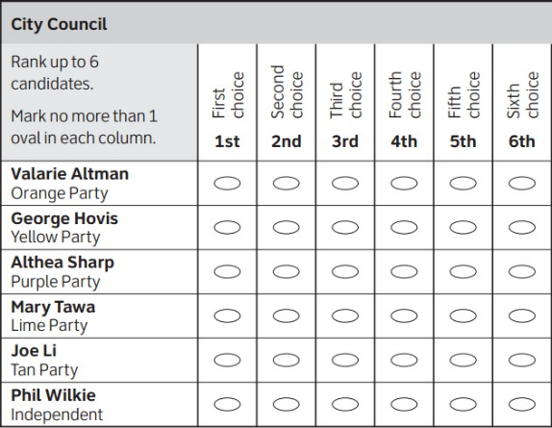Now that we have studied how to apportion the number of representatives for each state, we want to look at how representatives and other public officials are elected. There are also many other situations where a group consensus is needed, and some type of voting occurs. You may be most familiar with systems where you get one vote and the candidate with the most votes wins. However, there are many other ways of determining a winner. We will look at several voting methods in this section.

### Ranked Choice Ballots

To use some of the methods we are going to study, we need to know more than just each person’s first choice. We also need to know their 2nd and 3rd choices, and so on. A ballot where each person ranks all of the choices in order of their preference is called a **ranked choice ballot**. The image to the right shows an example of a ranked choice ballot. Let’s see how to tally the results from a ranked choice election.

Example 1: Students are voting for their class president and the candidates are Omar (O), Ana (A), and Helena (H). They have ranked the candidates according to their preference.

|  |  |  |  |  |  |  |  |  |  |  |
| --- | --- | --- | --- | --- | --- | --- | --- | --- | --- | --- |
|  | Vien | Ana | Marv | Tasha | Eve | Omar | Lupe | Dave | Helena | Jimmy |
| 1st choice | A | A | O | H | A | O | H | O | H | A |
| 2nd choice | O | H | H | A | H | H | A | H | A | H |
| 3rd choice | H | O | A | O | O | A | O | A | O | O |

### Preference Schedule

To simplify this data, we create a **preference schedule** which combines all the people who voted with the exact same ranking. For example, Tasha, Lupe, and Helena, all voted in the same way, HAO. So, we will list that combination once, with the number 3 at the top of that column. Three students also voted for AHO, and OHA. One student voted for the ranking AOH. Below is the preference schedule.

|  |  |  |  |  |
| --- | --- | --- | --- | --- |
|  | 1 | 3 | 3 | 3 |
| 1st choice | A | A | O | H |
| 2nd choice | O | H | H | A |
| 3rd choice | H | O | A | O |

Notice that by totaling the vote counts across the top of the preference schedule we can see the total number of votes cast: 1+3+3+3 = 10 total votes.

### Plurality Method

The voting method you may be most familiar with in the United States is the plurality method. In the **plurality method**, the candidate with the most first-choice votes is declared the winner.

There is a difference between a majority and a plurality. For a **majority**, a candidate must have over 50% of the votes. There are some states that require a majority in order to win an election. In more cases, though, only a plurality is required, which means having more votes than any other candidate. If a tie occurs without using ranked choice voting, then a new run-off election would be required.

Example 2: In our election from above, we had this preference table:

|  |  |  |  |  |
| --- | --- | --- | --- | --- |
|  | 1 | 3 | 3 | 3 |
| 1st choice | A | A | O | H |
| 2nd choice | O | H | H | A |
| 3rd choice | H | O | A | O |

For the plurality method, we only look at the 1st choice row. Totaling them up:

Ana: 1+3 = 4 votes

Omar: 3 votes

Helena: 3 votes

Ana is the winner using the plurality voting method.

Notice that Ana won with 4 out of 10 votes, or 40% of the votes, which is a plurality of the votes, but not a majority.

### How Many Votes are Needed to Win?

If we know how many voters there are, we can calculate the minimum number of votes needed for a majority win.

Continuing example 2 above, there are 10 voters, so we divide that by 2 or multiply by 0.5 to find 50%. Then we round up to the next whole number to get just over 50%.

. Then we round up to 6 votes.

Exactly half of the votes would be a tie, so we round up to the next whole number. A candidate would need 6 out of 10 votes to win a majority. If there was an odd number of voters we would divide by 2 and get a decimal. Let’s say there were 13 voters:

. Then we round up to the next whole number, which is 7 votes. A candidate can win a plurality with fewer votes than the majority, as long as they have more than any other candidate.

### Insincere Voting

In a system with only two major political parties like the United States, it can be nearly impossible for third-party candidates to break through. You may feel like you would be wasting your vote if you voted for a third-party candidate. Consider this example.

Example 3: Here is a two-party election with preferences shown below. It is a close race, but candidate B would win.

|  |  |  |
| --- | --- | --- |
| Number of voters | 96 | 100 |
| 1st choice | A | B |
| 2nd choice | B | A |

Suppose a third candidate, C, entered the race, and a segment of voters sincerely want to vote for that third candidate. Here is the new preference schedule.

|  |  |  |  |
| --- | --- | --- | --- |
| Number of voters | 96 | 90 | 10 |
| 1st choice | A | B | C |
| 2nd choice | B | A | B |
| 3rd choice | C | C | A |

The ten people who prefer candidate C are in a bind because if they vote for C, then A will win, but they prefer B over A. It is likely that they will vote for B, their second choice, to keep A from winning.

Situations like this can lead to insincere voting. **Insincere voting** is when a person doesn’t vote according to their actual preference for strategic purposes. In the case above, a person who wants to vote for a third-party candidate realizes it would take a vote away from their major party candidate. Not wanting to see their party lose the election, they vote for the major party candidate.

### Instant Runoff Method

The **Instant Runoff Method** is a modification of the plurality method that attempts to address the issue of insincere voting.

The voting is done with ranked choice ballots and a preference schedule is generated. Then we tally all the first-choice votes. The candidate with the *least* first-place votes is eliminated, but any votes for that candidate are transferred to the voters’ next choice. The process continues until one candidate has a majority. We will show you how it works with an example.

Example 4: Consider the preference schedule below, in which a committee is choosing a chairperson. The candidates are labeled A, B, C, D, and E for simplicity. Here is the preference schedule:

|  |  |  |  |  |  |  |  |
| --- | --- | --- | --- | --- | --- | --- | --- |
|  | 3 | 5 | 1 | 5 | 7 | 2 | 1 |
| 1st choice | B | C | C | B | D | A | E |
| 2nd choice | C | A | B | D | C | E | D |
| 3rd choice | A | E | B | C | A | B | B |
| 4th choice | D | D | E | A | E | C | A |
| 5th choice | E | B | A | E | B | D | C |

Let’s start by tallying the first-choice votes by adding the number of voters in the top row:

A: 2 B: 3+5=8 C: 5+1=6 D: 7 E: 1

If this was a plurality election, B would be the winner with 8 first-choice votes.

**Round 1:** We make our first elimination. Choice E has the fewest first-place votes, so we eliminate E from the election. To transfer the 1 vote, we look at the person who voted for E in the last column. Their second choice was D, so we transfer that one vote to D, who will now have 8 votes:

A: 2 B: 8 C: 6 D: 7 **~~E: 1~~**

**+1**

**8**

**Round 2:** There are 24 votes in total, so a majority would be 13 votes. Since no candidate has the majority, we eliminate the next candidate with the fewest votes, which is A. We look at the column for the two people who chose A. Their second choice was E, who is already eliminated. Their third choice is B, so their 2 votes are transferred to B, for a total of 10:

**~~A: 2~~** B: 8 C: 6 D: 7 ~~E: 1~~

**+2** +1

**10** 8

**Round 3:** Now C has the fewest votes, and the there are two columns for C in the preference schedule. Five people who voted for C chose A second, then E (who have already been eliminated), then D. So, we transfer their 5 votes to D. One person who voted for C selected B as their second choice, so their one vote goes to B. Then we tally the votes for each remaining candidate.

~~A: 2~~ B: 8 ~~C: 6~~ D: 7 ~~E: 1~~

+2 +1

10 8

**+1 +5**

**11 13**

Now we can see that D is the winner of the instant runoff method with 13 votes. We can stop this method earlier if a candidate reaches a majority.

The Instant Runoff Method is similar to the idea of holding runoff elections, but since every voter’s order of preference is recorded on the ballot, the runoff can be computed quickly without requiring a second costly election. It also makes it safe to vote for a third-party candidate knowing that your vote will go to your second choice if your first choice can’t win.

This voting method is used in several places around the world, including the election of members of the Australian House of Representatives, statewide elections in Maine, and local elections in Benton County, Oregon[4]. A version of the Instant Runoff Method is used by the International Olympic Committee to select host nations.

### Borda Count (Point System)

Borda Count is another voting method, named for Jean-Charles de Borda, who developed the system in 1770. In this method, points are assigned to each candidate based on their ranking; 1 point for last choice, 2 points for second-to-last choice, and so on. The point values are totaled, and the candidate with the largest point total is the winner. We’ll show you how to do it in the next example.

Example 5: A group of PCC students are getting together for a student leadership conference and they need to decide where to meet. Their members are from four campuses: Sylvania, Rock Creek, Cascade and Southeast. The votes for where to hold the conference were:

|  |  |  |  |  |
| --- | --- | --- | --- | --- |
|  | 31 | 25 | 10 | 14 |
| 1st choice | Sylvania | Rock Creek | Southeast | Cascade |
| 2nd choice | Southeast | Cascade | Cascade | Rock Creek |
| 3rd choice | Rock Creek | Sylvania | Sylvania | Southeast |
| 4th choice | Cascade | Southeast | Rock Creek | Sylvania |

Now we will add a column on the left side of the table for the points. Then we multiply the points by the number of voters who put each candidate in that rank.

|  |  |  |  |  |  |
| --- | --- | --- | --- | --- | --- |
| Points |  | 31 | 25 | 10 | 14 |
| 4 | 1st choice | Sylvania | Rock Creek | Southeast | Cascade |
| 3 | 2nd choice | Southeast | Cascade | Cascade | Rock Creek |
| 2 | 3rd choice | Rock Creek | Sylvania | Sylvania | Southeast |
| 1 | 4th choice | Cascade | Southeast | Rock Creek | Sylvania |

We will start with Sylvania in the bottom row and move up. They have one point times 14 voters, 2 points times 25 + 10 voters, 3 points times zero, and 4 points times 31 voters. Multiplying and then adding gives us a total of 208 points for Sylvania. You can see the calculation below and we will do the same thing for each campus:

Sylvania:  points

Rock Creek: 214 points

Cascade:  points

Southeast:  points

Using the Borda count method, Rock Creek is the winning location.

Note that Sylvania would have won with the plurality method. Borda count is sometimes described as a consensus-based voting system, since it can be used to choose a more broadly acceptable option over the one with the most first-choice support. This is a different approach than plurality and instant runoff voting that focus on first-choice votes; Borda Count considers every voter’s entire ranking to determine the outcome.

Because of this consensus behavior, Borda Count, or some variation of it, is commonly used in awarding sports awards. Variations are used to determine the Most Valuable Player in baseball, to rank teams in NCAA sports, and to award the Heisman trophy.

### Pairwise Comparison (Copeland’s or Condorcet Method)

Another method, called **pairwise comparison** or the **Condorcet method** or **Copeland’s method**, attempts to be fair by looking at each pair of candidates separately.

In this method, we look at each pair as if they were the only two candidates running and determine which of the two is more preferred. In Copeland’s method, the more preferred candidate is awarded 1 point. If there is a tie, each candidate is awarded ½ point. After all the pairwise comparisons are made, the candidate with the most points, and hence the most pairwise wins, is declared the winner.

Variations of Copeland’s Method are used in many professional organizations, including election of the Board of Trustees for the Wikimedia Foundation that runs Wikipedia.

Example 6: Consider our class president example from the beginning of the chapter. Determine the winner using Copeland’s Method.

|  |  |  |  |  |
| --- | --- | --- | --- | --- |
|  | 1 | 3 | 3 | 3 |
| 1st choice | A | A | O | H |
| 2nd choice | O | H | H | A |
| 3rd choice | H | O | A | O |

We need to look at each pair of candidates to see which would win in a one-to-one comparison. First, we will systematically list all of the pairs of candidates:

Helena vs. Omar Ana vs. Omar

Helena vs. Ana

Next, comparing Helena with Omar, we see that 6 voters, those shaded in the table below, would prefer Helena to Omar. Note that Helena doesn’t have to be the voter’s first choice – we’re imagining that Ana wasn’t in the race. The other 4 people chose Omar over Helena.

|  |  |  |  |  |
| --- | --- | --- | --- | --- |
|  | 1 | 3 | 3 | 3 |
| 1st choice | A | A | O | H |
| 2nd choice | O | H | H | A |
| 3rd choice | H | O | A | O |

Based on this comparison of Helena vs. Omar, Helena wins 1 point.

Next, comparing Helena with Ana, the 6 voters in the last two columns prefer Helena to Ana, so Helena gets one point. Lastly, we compare Ana with Omar. The 1 voter in the first column prefers Ana, as do the 3 voters in the second column. The 3 voters in the third column prefer Omar, but the 3 voters in the last column would choose Ana. So, altogether 1+3+3=7 voters prefer Ana over Omar. Ana gets 1 point.

To summarize, we write how many voters prefer each candidate ignoring all other candidates:

Helena-6 vs Omar-4 Ana-7 vs Omar-3

(Helena gets 1 point) (Ana gets 1 point)

Helena-6 vs Ana-4

(Helena gets 1 point)

Ana has a total of 1 point and Helena has 2 points, so Helena is the winner under Copeland’s Method. This method gave us a different winner than the plurality method where Ana won, because more people preferred Helena to Ana, even though they didn’t choose Helena for their first choice.

Now that we’ve seen an example of each voting method, let’s run through each method for the same scenario.

Example 7: Consider an advertising team voting to choose one of four different slogans, labeled A, B, C and D. Determine the winner using each method we have learned.

|  |  |  |  |  |  |
| --- | --- | --- | --- | --- | --- |
|  | 5 | 3 | 6 | 4 | 2 |
| 1st choice | D | A | C | B | A |
| 2nd choice | A | C | B | D | D |
| 3rd choice | C | B | A | A | C |
| 4th choice | B | D | D | C | B |

Solution in drop down box

**Plurality Method:** We tally the first-place votes:

A: 3+2=5 B: 4 C: 6 D: 5 C wins the plurality method.

**Instant Runoff Method:** We start with the plurality tallies. Then we look for the slogan with the least first-choice votes, and that is B. Looking in the preference schedule at the 4 people who voted for B, we see their second choice is D. So we transfer those 4 votes to D, which now has 9.

A: 5 ~~B: 4~~ C: 6 D: 5

**+4**

**9**

Now A has the least number of votes with 5, so we look at the voters who chose A for their first choice. There are two columns, so three of those votes will be transferred to C and 2 will be transferred to D.

~~A: 5~~ ~~B: 4~~ C: 6 D: 5

+4

9

**+3 +2**

**9 11** D is the winner of the instant runoff method.

**Borda Count:** We add a column on the left for the points, starting with 1 point for last place and counting up. Then we multiply the points by the number of votes and add them all up.

|  |  |  |  |  |  |  |
| --- | --- | --- | --- | --- | --- | --- |
| Points |  | 5 | 3 | 6 | 4 | 2 |
| 4 | 1st choice | D | A | C | B | A |
| 3 | 2nd choice | A | C | B | D | D |
| 2 | 3rd choice | C | B | A | A | C |
| 1 | 4th choice | B | D | D | C | B |

A: 55 points

B: points

C:  points

D: points A is the winner of the Borda count method.

**Pairwise Comparison:** First we list all the possible pairs:

A vs B B vs C C vs D

A vs C B vs D

A vs D

Then we count the number of voters who would choose each candidate if they were the only two in the race.

A-10 vs B-10 B–4 vs C-16 C-9 vs D-11

A-14 vs C-6 B-13 vs D-7

A-11 vs D-9

Totaling one point for each win and half a point for each tie gives us:

A has 2 ½ points

B has 1 ½ points

C has 1 point

D has 1 point

A is the winner of the pairwise comparison method.

### Which Method is the Most Fair?

To see a very simple example of how difficult voting can be, consider the election below:

|  |  |  |  |
| --- | --- | --- | --- |
|  | 5 | 5 | 5 |
| 1st choice | A | C | B |
| 2nd choice | B | A | C |
| 3rd choice | C | B | A |

Notice that in this election:

10 people prefer A to B

10 people prefer B to C

10 people prefer C to A

No matter whom we choose as the winner, 2/3 of voters would prefer someone else! This scenario is dubbed Condorcet’s Voting Paradox. In this situation, there is no fair resolution. There are many additional paradoxes and fairness criteria that are explained in David Lippman’s original version of Math in Society[5].

Since it is not possible to have one method that is fair in every situation, we need all of these different methods. It is important to decide which method is the most fair for any given situation.

### Primaries and Sequential Voting

For many public offices in the U.S., a sequence of two public votes is held: a primary election and the general election. For non-partisan offices like sheriff and judge, in which political party affiliation is not declared, the primary election is usually used to narrow the field of candidates.

For partisan positions, typically, either the top two candidates receiving the most votes move forward, or the top candidate from each party will move forward. This is called **sequential voting** - a process in which voters cast totally new ballots after each round of eliminations. Sequential voting has become quite common in television, where it is used in reality competition shows like the Voice.

In some states a **closed primary** is used, in which only voters of each party can vote for that party’s candidates. In other states, an **open primary** is used, where voters can pick the party whose primary they want to vote in. In other states, **caucuses** are used, which are meetings of the political parties, only open to party members. Closed primaries are often disliked by independent voters, who like the flexibility to change which party they are voting in. Open primaries have the disadvantage of raiding, though, where a voter could vote in their non-preferred party’s primary with the intent of selecting a weaker opponent for their preferred party’s candidate.

Regardless of the primary type, the general election is the main election, open to all voters. While rules vary state-to-state, for an independent or minor party candidate to get listed on the ballot, they typically have to gather a certain number of signatures to petition for inclusion.

In the next section we will look at a different type of election for the President of the United States.

## Exercises 5.2

1. To decide on a new website design, the designer asks people to rank three designs that have been created (labeled A, B, and C). The individual ballots are shown below. Create a preference table.

ABC, ABC, ACB, BAC, BCA, BCA, ACB, CAB, CAB, BCA, ACB, ABC

1. To decide on a movie to watch, a group of friends all vote for one of the choices (labeled A, B, and C). The individual ballots are shown below. Create a preference table.

CAB, CBA, BAC, BCA, CBA, ABC, ABC, CBA, BCA, CAB, CAB, BAC

1. The planning committee for a renewable energy trade show is trying to decide what city to hold their next show in. The votes are shown below.

|  |  |  |  |  |
| --- | --- | --- | --- | --- |
| Number of voters | 9 | 19 | 11 | 8 |
| 1st choice | Buffalo | Atlanta | Chicago | Buffalo |
| 2nd choice | Atlanta | Buffalo | Buffalo | Chicago |
| 3rd choice | Chicago | Chicago | Atlanta | Atlanta |

1. How many voters voted in this election?
2. How many votes are needed for a majority?
3. Find the winner under the plurality method.
4. Find the winner under the Instant Runoff Voting method.
5. Find the winner under the Borda Count Method.
6. Find the winner under Copeland’s method.
7. A non-profit agency is electing a new chair of the board. The votes are shown below.

|  |  |  |  |  |
| --- | --- | --- | --- | --- |
| Number of voters | 11 | 5 | 10 | 3 |
| 1st choice | Atkins | Cortez | Burke | Atkins |
| 2nd choice | Cortez | Burke | Cortez | Burke |
| 3rd choice | Burke | Atkins | Atkins | Cortez |

1. How many voters voted in this election?
2. How many votes are needed for a majority?
3. Find the winner under the plurality method.
4. Find the winner under the Instant Runoff Voting method.
5. Find the winner under the Borda Count Method.
6. Find the winner under Copeland’s method.
7. The student government is holding elections for president. There are four candidates (labeled A, B, C, and D for convenience). The preference schedule for the election is:

|  |  |  |  |  |  |  |
| --- | --- | --- | --- | --- | --- | --- |
| Number of voters | 120 | 50 | 40 | 90 | 60 | 100 |
| 1st choice | C | B | D | A | A | D |
| 2nd choice | D | C | A | C | D | B |
| 3rd choice | B | A | B | B | C | A |
| 4th choice | A | D | C | D | B | C |

1. How many voters voted in this election?
2. How many votes are needed for a majority?
3. Find the winner under the plurality method.
4. Find the winner under the Instant Runoff Voting method.
5. Find the winner under the Borda Count Method.
6. Find the winner under Copeland’s method.
7. The homeowner’s association is deciding a new set of neighborhood standards for architecture, yard maintenance, etc. Four options have been proposed. The votes are:

|  |  |  |  |  |  |  |
| --- | --- | --- | --- | --- | --- | --- |
| Number of voters | 8 | 9 | 11 | 7 | 7 | 5 |
| 1st choice | B | A | D | A | B | C |
| 2nd choice | C | D | B | B | A | D |
| 3rd choice | A | C | C | D | C | A |
| 4th choice | D | B | A | C | D | B |

1. How many voters voted in this election?
2. How many votes are needed for a majority?
3. Find the winner under the plurality method.
4. Find the winner under the Instant Runoff Voting method.
5. Find the winner under the Borda Count Method.
6. Find the winner under Copeland’s method.

### Exploration Questions

1. The Coombs method is a variation of instant runoff voting. In Coombs method, the choice with the most last place votes is eliminated. Apply Coombs method to the preference schedules from questions 5 and 6.
2. Copeland’s Method is designed to identify a Condorcet Candidate if there is one, and is considered a Condorcet Method. There are many Condorcet Methods, which vary primarily in how they deal with ties, which are very common when a Condorcet winner does not exist. Copeland’s method does not have a tie-breaking procedure built-in. Research the Schulze method, another Condorcet method that is used by the Wikimedia foundation that runs Wikipedia, and give some examples of how it works.
3. Instant Runoff Voting and Approval voting have supporters advocating that they be adopted in the United States and elsewhere to decide elections. Research comparisons between the two methods describing the advantages and disadvantages of each in practice. Summarize the comparisons, and form your own opinion about whether either method should be adopted.
4. In a primary system, a first vote is held with multiple candidates.  In many states, where voters must declare a party to vote in the primary election, and they are only able to choose between candidates for their declared party. The top candidate from each party then advances to the general election.  Compare and contrast this primary with general election system to instant runoff voting, considering both differences in the methods, and practical differences like cost, campaigning, fairness, etc.
5. Sometimes in a voting scenario it is desirable to rank the candidates, either to establish preference order between a set of choices, or because the election requires multiple winners. For example, a hiring committee may have 30 candidates apply, and need to select 6 to interview, so the voting by the committee would need to produce the top 6 candidates. Describe how Plurality, Instant Runoff Voting, Borda Count, and Copeland’s Method could be extended to produce a ranked list of candidates.

## Section 5.3 The Popular Vote, Electoral College and Electoral Power

### Choosing the U.S. President

In the last section we studied several voting methods. To choose the President of the United States, we use a different method, called the **Electoral College**. The Founders, with their newfound freedom from Britain, wanted to create a democracy where citizens could participate in choosing their president. Prior to the Electoral College, there were three options proposed. They were

1. Congress would elect the president
2. State Legislatures would vote and elect the president
3. The people would elect a president by popular vote (Best, 2004; Clayton, 2015).

The first option of having Congress do this work was declined as this would alter the balance of power among the three separate branches of government. The idea to have State Legislatures also failed as there wouldn’t be the separation between having an independent Federal Government and State Governments.

The **popular vote** means a candidate must win a plurality of all the votes cast for president, regardless of which state the voters live in. The popular vote was decided against as they didn’t think all citizens would be informed enough about the candidates to make an educated decision (Clayton, 2015).

Instead, the **Electoral College** was decided upon and, in this system, each state was given a certain number of electoral votes. Each state got an equal two votes for the two senate seats. This gave smaller states a leg up as they would have at least these votes. In addition to this, each state would be given more votes based on their population, equal to their representation in the House (Clayton, 2015). The District of Columbia, which is not a state, also gets 3 electoral votes. A candidate must win a majority of the electoral votes to win the U.S. presidency. If no candidate has a majority then a contingent election would be held by the U.S. House of Representatives between the three candidates with the most electoral votes.

The 4 million U.S. Citizens who live in the territories of Guam, the Virgin Islands, the Northern Mariana Islands and Puerto Rico cannot vote in the presidential elections and do not have any electors for the U.S. President. Additionally, there are U.S. Nationals in American Samoa and other territories that cannot vote. You can learn more about residents of these territories in [this Census Bureau report](https://www.census.gov/prod/2011pubs/12statab/outlying.pdf).

The U.S. currently has 435 representatives in the House. They each serve 2-year terms, while the two senators from each state serve 6-year terms.

Example: How many electoral votes are there in the U.S. Electoral College?

Answer in drop down box:



By adding all the U.S. Senators, Representatives and 3 for Washington, D.C., we have a total of 538 electoral votes.

Example: How many electoral votes does a candidate need to win to become the President of the United States?

Answer in drop down box:

 then round up to 270.

A candidate needs 270 electoral votes to win the U.S. Presidency.

Example: The number of people who voted in the presidential election in 2016 was 136,452,150[6]. How many votes would be needed to win a majority of the popular vote?

Answer in drop down box:

 then round up to 68,226,076.

A candidate would need 68,226,076 votes to win the popular vote.

Example: There were approximately 230,931,921 eligible voters at the time of the 2016 election[7]. What percentage of eligible voters voted?

Answer in drop down box:



About 59% of all the eligible voters voted in the 2016 election.

If you are interested in the 2016 election voting rates by race, Hispanic origin and age, you can find them in this [Census Bureau report](https://www.census.gov/newsroom/blogs/random-samplings/2017/05/voting_in_america.html).

### How Electoral Votes are Determined

While each state has a set number of electoral votes based on the formula above, the federal government gave states the control of how they distribute and cast their electoral votes (Paiva, 2011). In 48 states, the candidate with the most votes wins all of that state’s electoral votes. In essence, a candidate could win with barely a majority of the popular vote in that state and the entire state’s votes goes to that individual (Clayton, 2015). In 2 states, Maine and Nebraska, they use a district plan where instead of winner-takes-all, they use proportionality. This means that they award electoral votes by how individual districts vote. Each district gives their electoral vote to the winner of their district and the remaining two votes go to the candidate that won statewide.

There is a movement to change from the Electoral College to the popular vote. One way this is happening is through the [National Popular Vote Interstate Compact](https://www.nationalpopularvote.com/). States who adopt this compact, agree to award their electoral votes to the winner of the national popular vote. If states and/or D.C. with at least 270 electoral votes adopt this compact, then the winner of the popular vote would win the electoral college and the presidency. At this time there are 196 electoral votes in states and D.C. who have enacted the bill and the bill has passed one or two legislative houses in additional states with 88 electoral votes.

After citizens cast their votes on election day in November, electors gather in December and are responsible for casting the votes for their state. Electors cannot be elected officials and are chosen by their parties. Electors are expected to vote in alignment with the state they represent, but there have been faithless electors in the past. The U.S. Supreme Court just ruled in July of 2020 that states can penalize electors who do not vote according to the law of the state.

To see how the electoral college and popular votes work, we will look at a made-up country with a smaller number of states.

**Example:**

Consider this country with 4 states. The rules for the number of senators and electors are the same as the U.S. government. Each state will get 1 representative for every 40,000 residents. For simplicity we will ignore any remainders.

|  |  |  |  |  |
| --- | --- | --- | --- | --- |
| **State** | **Population** | **Number of Representatives** | **Number of Senators** | **Number of Electors** |
| Small | 154,600 |  |  |  |
| Medium | 262,340 |  |  |  |
| Large | 581,135 |  |  |  |
| Huge | 1,362,070 |  |  |  |

a. Determine the number of electors for each state and the total for the country.

b. How many electoral votes are needed to win the presidential election?

c. Determine which candidate wins the popular vote and the electoral college vote.

d. Write down all the possible combinations of states that would win the election based on the electoral college.

e. What is the fewest number of individual votes needed to win the Electoral College?

f. What is the smallest percentage of the population that you can win the Electoral College with?

Solution

a. To find the number of electors for each state, we first divide each state population by 40,000 to determine the number of representatives they will have. We will drop the decimal remainders, similar to Hamilton’s method.

|  |  |  |  |  |
| --- | --- | --- | --- | --- |
| **State** | **Population** | **Number of Representatives** | **Number of Senators** | **Number of Electors** |
| Small | 154,600 |  |  |  |
| Medium | 262,340 |  |  |  |
| Large | 581,135 |  |  |  |
| Huge | 862,070 |  |  |  |

Next, we will fill in 2 senators for each state.

|  |  |  |  |  |
| --- | --- | --- | --- | --- |
| **State** | **Population** | **Number of Representatives** | **Number of Senators** | **Number of Electors** |
| Small | 154,600 | 3 | 2 |  |
| Medium | 262,340 | 6 | 2 |  |
| Large | 581,135 | 14 | 2 |  |
| Huge | 862,070 | 21 | 2 |  |

Then we will add the number of representatives and the senators for each state.

|  |  |  |  |  |
| --- | --- | --- | --- | --- |
| **State** | **Population** | **Number of Representatives** | **Number of Senators** | **Number of Electors** |
| Small | 154,600 | 3 | 2 | 5 |
| Medium | 262,340 | 6 | 2 | 8 |
| Large | 581,135 | 14 | 2 | 16 |
| Huge | 862,070 | 21 | 2 | 23 |
| Totals | 1,860,145 | 44 | 8 | 52 |

Now we can add up the total of all the electors from each state and we have

5 + 8 + 16 + 23 = 52 electors.

b. To find out how many electoral votes are needed to win the presidential election, we calculate a majority of 52 electors.

, round up to 27

27 electoral votes are needed to win the presidential election in this state.

c. To find the winner for each method, we need the results of an election. In our example, there are 2 candidates for the president, Candidate A and Candidate B. When a candidate wins in a state, they get all the electoral votes for that state. Given the votes for each candidate below, determine who wins the popular vote and who wins the electoral college vote.

|  |  |  |  |  |
| --- | --- | --- | --- | --- |
| **State** | **Votes for Candidate A** | **Votes for Candidate B** | **Number of Electoral Votes for A** | **Number of Electoral Votes for B** |
| Small | 56,259 | 98,341 |  |  |
| Medium | 130,082 | 132,258 |  |  |
| Large | 278,177 | 302,958 |  |  |
| Huge | 546,555 | 315,515 |  |  |
| Total Votes |  |  |  |  |

First, we will add up all the votes for each candidate in their columns. Next, we will look at each state individually to determine which candidate wins each state. Candidate B has more votes in Small, Medium and Large, so Candidate B gets all of the electoral votes in those states. Candidate A won Huge, so they get all of those electoral votes. We enter zero for the candidate who does not win in each state. Then we add up the electoral vote columns. Here is the completed table.

|  |  |  |  |  |
| --- | --- | --- | --- | --- |
| **State** | **Votes for Candidate A** | **Votes for Candidate B** | **Number of Electoral Votes for A** | **Number of Electoral Votes for B** |
| Small | 56,259 | 98,341 | 0 | 5 |
| Medium | 130,082 | 132,258 | 0 | 8 |
| Large | 278,177 | 302,958 | 0 | 16 |
| Huge | 546,555 | 315,515 | 23 | 0 |
| Total Votes | 1,011,073 | 849,072 | 23 | 29 |

Now we can see that Candidate A wins the popular vote with 1,011,073 votes compared to 849,072 for Candidate B. But Candidate B wins the Electoral College with 29 electoral votes. So, Candidate B becomes the President of the United States.

There have been 5 U.S. presidential elections where the winner of the popular vote was not the winner of the electoral college. In all the other elections, the two methods agreed and would have elected the same candidate.

Try calculating the results if these were the votes instead:

|  |  |  |  |  |
| --- | --- | --- | --- | --- |
| **State** | **Votes for Candidate A** | **Votes for Candidate B** | **Number of Electoral Votes for A** | **Number of Electoral Votes for B** |
| Small | 56,259 | 98,341 |  |  |
| Medium | 131,200 | 131,140 |  |  |
| Large | 278,177 | 302,958 |  |  |
| Huge | 546,555 | 315,515 |  |  |
| Total Votes |  |  |  |  |

Solution in dropdown box:

|  |  |  |  |  |
| --- | --- | --- | --- | --- |
| **State** | **Votes for Candidate A** | **Votes for Candidate B** | **Number of Electoral Votes for A** | **Number of Electoral Votes for B** |
| Small | 56,259 | 98,341 | 0 | 5 |
| Medium | 131,200 | 131,140 | 8 | 0 |
| Large | 278,177 | 302,958 | 0 | 16 |
| Huge | 546,555 | 315,515 | 23 | 0 |
| Total Votes | 1,012,191 | 847,954 | 31 | 21 |

This time Candidate A won Medium and Huge. That gave them the electoral vote victory. Note that the race in Medium was very close, and we only changed 1,118 votes or 0.06% of the votes to Candidate A which gave them the Electoral College.

Opponents of the Electoral College system say that it causes candidates to focus on a few swing states, rather than campaigning equally in all states.

d. Let’s look at which combinations of states the candidates could seek to win with.

Since 27 electoral votes are needed, we will list all the winning combinations starting with the smallest number of states to win. We see that a candidate must win either Huge or Large, because Small and Medium together are not enough votes to win.

|  |  |  |  |  |  |
| --- | --- | --- | --- | --- | --- |
| Combination | Small, 5 | Medium, 8 | Large, 16 | Huge, 23 | Total |
| Huge + Small | 5 |  |  | 23 | 28 |
| Huge + Medium |  | 8 |  | 23 | 31 |
| Huge + Large |  |  | 16 | 23 | 39 |
| Huge + Small + Medium | 5 | 8 |  | 23 | 36 |
| Huge + Medium + Large |  | 8 | 16 | 23 | 47 |
| Huge + Small + Large | 5 |  | 16 | 23 | 44 |
| Large + Small + Medium | 5 | 8 | 16 |  | 29 |
| All States | 5 | 8 | 16 | 23 | 52 |

From the table we find there are 8 different ways to win the electoral college and candidates should definitely campaign in Large and Huge.

e. To find the fewest number of individual votes a candidate could win with; let’s look at the table above. The combination of states with the fewest electoral votes is Huge and Small. Let’s see how many votes would be needed to win those two states.

For Huge,

, then round up to 431,036

For Small,

, then round up to 77,301

431,036 + 77,301 votes = 508,337 votes.

f. The smallest number of votes to win the electoral college is 508,337. What percentage of the population is that? We will divide by the total population to get



If a candidate had the right combination of states, they could win the Electoral College with only 27.3% of the vote.

People who support the Electoral College often say it protects small states. People who oppose the Electoral College often say that each person’s vote should count equally as in the popular vote. Next we will look at electoral power to understand the effect on small states.

### Electoral Power

**Electoral power** is the value of a person’s vote in one state compared to another state. A related topic is voting power, which is the probability of any one person influencing an election. If you are interested in voting power, you can look up the Banzhaf Power Index. To calculate the electoral power, we will calculate a ratio of electoral votes for a given number of people. We could use any number, so we will choose the number of people that each representative represents, which is our divisor of 40,000 people.

Example: Using the same fictional country, use the table below to calculate the electoral power of each state.

|  |  |  |  |  |  |
| --- | --- | --- | --- | --- | --- |
| **State** | **Population** | **Number of Representatives** | **Number of Senators** | **Number of Electors** | **Electoral Votes per 40,000 people** |
| Small | 154,600 |  |  |  |  |
| Medium | 262,340 |  |  |  |  |
| Large | 581,135 |  |  |  |  |
| Huge | 1,362,070 |  |  |  |  |

First, we fill in the number of representatives, senators and electoral votes for each state that we found earlier. Then we will calculate the number of electoral votes per 40,000 people.

To do that, divide the number of electors by the number of representatives, since they each represent approximately 40,000 people. The results are shown in the table below. Note this is approximate because we cut off the decimal remainders when calculating the number of representatives.

|  |  |  |  |  |  |
| --- | --- | --- | --- | --- | --- |
| **State** | **Population** | **Number of Representatives** | **Number of Senators** | **Number of Electors** | **Electoral Votes per 40,000 people** |
| Small | 154,600 | 3 | 2 | 5 |  |
| Medium | 262,340 | 6 | 2 | 8 |  |
| Large | 581,135 | 14 | 2 | 16 |  |
| Huge | 1,362,070 | 21 | 2 | 23 |  |

Are you surprised to see that the smallest states have the highest electoral power? That is part of the design of the electoral college. The founders from small states were concerned that their votes would not matter, so every state gets 2 senators added to the number of representatives. For a state with few representatives, those 2 extra electoral votes make a big difference. For a large states, the extra 2 electoral votes don’t make a very big difference.

You may have noticed a pattern when dividing to find the electoral power. Each time we divided the number of electoral votes by that number minus two. We can write that pattern as . Using GeoGebra to graph that pattern this is what we see.

Electoral Power in the Current Electoral College

Electoral Power

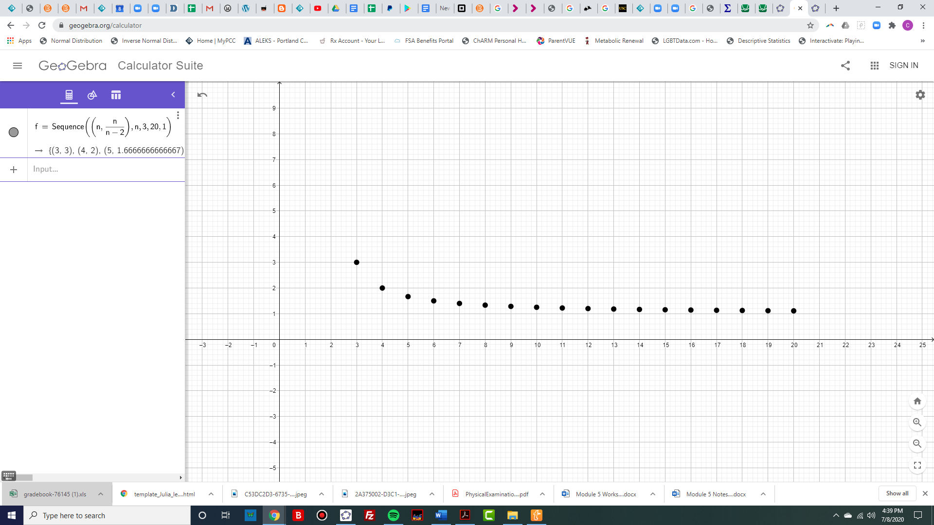

Number of Electors

The minimum number of electors is three, since each state gets at least one representative in the apportionment process. The smallest states and Washington, D.C. have 3 electors and the greatest electoral power on the left side of the graph. The largest states like California, Florida and Texas have the least electoral power on the right side of the graph.

Let’s say instead each state had equal electoral power by removing the 2 extra electoral votes or by using the popular vote. Then the graph would look like this.

Electoral Power without the 2 additional Electors Per State

Electoral Power

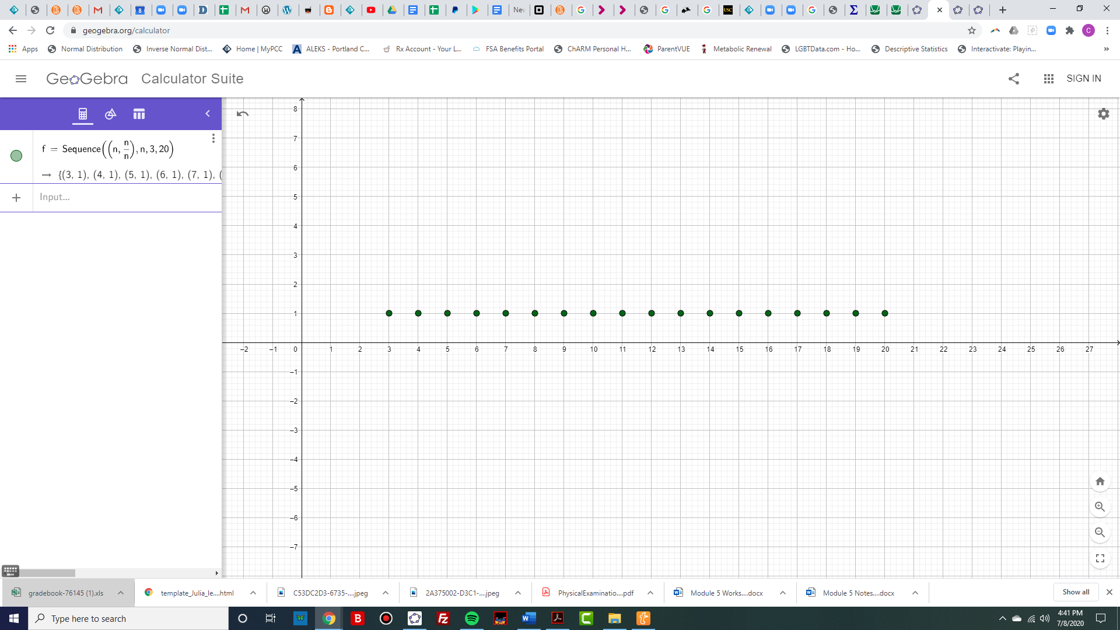

Number of Electors

Now that we have studied the popular vote, the Electoral College and electoral power, we leave it up to you to choose which method you think is best.

## Exercises 5.3

## Section 5.4 Gerrymandering and How to Measure It

### Forming State Legislative Districts

As we saw in section 5.1, the U.S. House of Representatives has 435 seats that are re-apportioned among the states every 10 years after the census. For example, in Oregon we currently have 5 legislative districts. After the 2020 census is finished, that number could change. It has been projected that Oregon may get a 6th representative due to population growth from 2010 to 2020.

After the reapportionment, it is up to each state government to divide their population into equal districts which each elect their representative to the U.S. House. As this Mail Tribune article[8] suggests, it may be challenging to draw new boundaries to change Oregon from 5 to 6 districts.

Each representative should represent approximately the same number of people, but their areas may not be the same. Due to different population densities in urban and rural areas, you can see in the map of Oregon that the districts are not geographically equal.

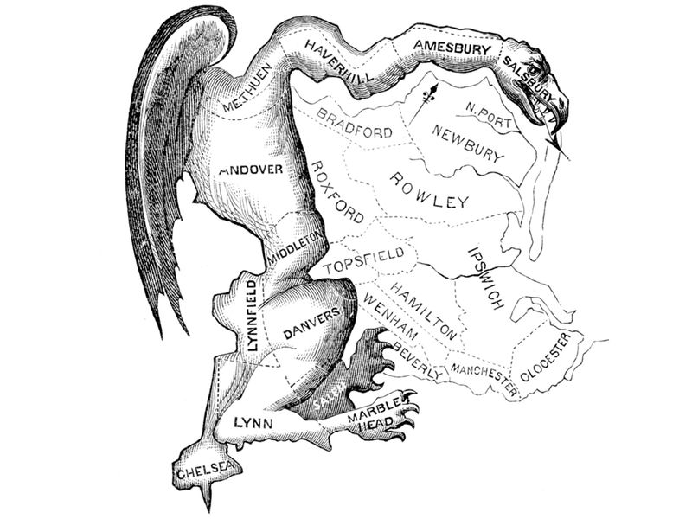Currently in most states, the state legislature draws the district boundaries. That means the party in power is in charge of drawing the new districts and they could redraw the lines to help their own party. This is called gerrymandering. **Gerrymandering**,pronounced, “Jerrymandering,” is when districts are drawn to the political advantage of those drawing the boundaries.

Gerrymandering got its name from Elbridge Gerry, the governor of Massachusetts who signed a bill in 1812 that created the unusual district pictured here that looked like a salamander. It gave then Democrat-Republicans a bigger state Senate majority, even though the Federalist party got more votes statewide.

Some other well-known gerrymanders are Pennsylvania’s ”[Goofy Kicking Donald Duck](https://www.washingtonpost.com/blogs/the-fix/post/name-that-district-contest-winner-goofy-kicking-donald-duck/2011/12/29/gIQA2Fa2OP_blog.html)” and Ohio’s “[Lake Erie Monster](https://en.wikipedia.org/wiki/Ohio%27s_9th_congressional_district).”

Gerrymandering has occurred by both parties. Gerrymandering by race is illegal due to the Voting Rights Act of 1965, so people of color cannot be spread out to dilute their vote. Groups with similar interests may want to be put together to form voting blocks, but that is controversial. Gerrymandering by political party has been the subject of many lawsuits and Supreme Court cases. One of the challenges is how to measure gerrymandering to prove that it has occurred. The measurement must be easy to explain and understand in court.

Several ways to measure gerrymandering have been proposed. Some of the first methods used geometry to measure how compact a district is, rather than the sprawling salamander. But it has been shown that being compact does not equate with fairness. More recent methods use computer simulations to determine whether a certain map is an extreme outlier compared to other possible maps, or measure something called [partisan bias](https://projects.fivethirtyeight.com/partisan-gerrymandering-north-carolina/).

In this book we will focus on the efficiency gap, proposed in 2015 by Nicholas Stephanopoulos and Eric McGhee. The **efficiency gap** is a measure of the advantage one party has over the other party due to the partisanship of the voters in each district.

We will learn how to calculate and interpret the efficiency gap. First, let’s look at a simplified state map and draw some districts.

### How to Gerrymander

There are two main ways to gerrymander a map, by packing and cracking. **Packing** is when all the people of one political party are packed into a district. Since a party only needs a plurality or majority to win, all those extra votes would be surplus. **Cracking** dilutes a party’s votes by spreading out the voters so they can’t win as many districts.

Here is a small sample map to see how this works. In this fictitious state, we have 35 people and 5 districts. So we will need 7 people in each district. You can see how they are spread out in the map below, with Republicans denoted by R’s and Democrats marked with D’s. To keep it simple, we are only looking at two parties and they will need a majority to win an election. We are also assuming that all voters will vote and that they vote according to their party which may not always be the case.

Figure 1. A simplified state map

### Proportionality

For a map to be fair, we would expect the portion of seats that a political party wins in an election to be about the same as the portion of that party in the state. This is called **proportionality**. For example, if a state is 50:50 Democrat to Republican, they should each get about half of the seats. There is nothing in the constitution that guarantees proportionality, but this is a basic measure of fairness.

For example, in our state above, we have a population that is close to 50:50, but an odd number of seats. How do we draw the district lines to be fair? We would expect to have either 3 Republicans and 2 Democrats or 2 Republicans and 3 Democrats. Before we draw a fair map, let’s try gerrymandering it for Democrats and then for the Republicans.

**Example 1:** We will first try to advantage the Democrats. There are 7 people in each district, so a party needs 4 votes to win the election. We will draw the lines to put 4 Democrats in each district along with 3 Republicans to spread them out by cracking. Here is our map.

Figure 2. The map gerrymandered in favor of Democrats

We were able to get 4 Democrats and 3 Republicans in districts 1, 2, 3 and 5. The Republicans will win in district 4 because it will be 5-2, but if the 5th Republican had been in another district, the map would have been more fair. As it is drawn, the population is 17:18 but the seats are 1:4, which does not seem fair.

### The Efficiency Gap

To try to measure how unfair the map is, let’s learn how to calculate the efficiency gap. First, we will tally the votes in the table below, and note how the election results would turn out by highlighting the party with more voters in each district. For example, there are 4 D’s and 3 R’s in district 1, so the Democrats would theoretically win that district.

|  |  |  |  |  |
| --- | --- | --- | --- | --- |
| **District** | **D Votes** | **R Votes** | **D Surplus Votes** | **R Surplus Votes** |
| 1 | **4** | **3** |  |  |
| 2 | **4** | **3** |  |  |
| 3 | **4** | **3** |  |  |
| 4 | **2** | **5** |  |  |
| 5 | **4** | **3** |  |  |
| **Total** | **18** | **17** |  |  |

Election Results:

Democrats win 4 seats

Republicans win 1 seat

Next, we will calculate how many votes would be extra over the amount needed to win the election. These are the **surplus votes**. In this example, with 7 voters, the majority of a district is 4 votes, so we will subtract 4 from each winning side. From each losing side, all of the votes are considered surplus because they did not go toward electing a candidate of their party. Then we add all the surplus votes for each party.

|  |  |  |  |  |
| --- | --- | --- | --- | --- |
| **District** | **D Votes** | **R Votes** | **D Surplus Votes** | **R Surplus Votes** |
| 1 | **4** | **3** | **4-4=0** | **3** |
| 2 | **4** | **3** | **4-4=0** | **3** |
| 3 | **4** | **3** | **4-4=0** | **3** |
| 4 | **2** | **5** | **2** | **5-4=1** |
| 5 | **4** | **3** | **4-4=0** | **3** |
| **Total** | **18** | **17** | **2** | **13** |

The difference between the surplus votes as a percentage of the population is the efficiency gap. As a formula it is written:



To get a positive result, we put the larger number first and we have

 or 31.4%.

The efficiency gap is 31.4%. To understand what this percentage means, we compare it with the percentage that each district represents in the state. Since our state has 5 districts, each one is 20% of the population. Here’s how we got that by dividing or as a fraction of the state.



or

 or 20%

In this case, the efficiency gap is worth more than one full seat, which suggests that the Democratic party has at least one extra seat than they would with proportional representation.

Example 2: For another example, we will take the same map and gerrymander it for the Republicans. This time we will pack as many Democrats as we can into the middle, and then use cracking to form the rest of the districts, trying to get 4 R’s in as many as we can. Here is the map.

Figure 3. The map gerrymandered in favor of Republicans

Now, let’s fill in our table:

|  |  |  |  |  |
| --- | --- | --- | --- | --- |
| **District** | **D Votes** | **R Votes** | **D Surplus Votes** | **R Surplus Votes** |
| 1 | **3** | **4** | **3** | **4-4=0** |
| 2 | **7** | **0** | **7-4=3** | **0** |
| 3 | **3** | **4** | **3** | **4-4=0** |
| 4 | **2** | **5** | **2** | **5-4=1** |
| 5 | **3** | **4** | **3** | **4-4=0** |
| **Total** | **18** | **17** | **14** | **1** |

Election Results:

Democrats win 1 seat

Republicans win 4 seats

To calculate our efficiency gap,

 or 37.1%.

This shows the opposite unfairness where the population is 17:18 but the seats are 4:1. We can calculate the number of seats that the efficiency gap is worth by dividing 37.1% by 20%.



The efficiency gap is worth approximately 1.9 seats.

Stephanopoulos and McGhee gave a guideline of around 8% or less for the efficiency gap and this one is 37.1%. The Republicans have at least one extra seat than they would if the seats were proportional to the population.

**Example 3:** Now we will try to create a fair map and see what the efficiency gap is. There are an odd number of districts and the population is 17:18 so it might be challenging to make it fair.

Figure 4. A more fair map

With this map, we tried to have two districts that favored Democrats, two that favored Republicans, and one that might go either way. Since there is one extra Democrat, the population is 17:18 and the seats are 2:3.

Let’s see how the efficiency gap comes out in this situation:

|  |  |  |  |  |
| --- | --- | --- | --- | --- |
| **District** | **D Votes** | **R Votes** | **D Surplus Votes** | **R Surplus Votes** |
| 1 | **3** | **4** | **3** | **4-4=0** |
| 2 | **4** | **3** | **4-4=0** | **3** |
| 3 | **4** | **3** | **4-4=0** | **3** |
| 4 | **3** | **4** | **3** | **4-4=0** |
| 5 | **4** | **3** | **4-4=0** | **3** |
| **Total** | **18** | **17** | **6** | **9** |

Election Results:

Democrats win 3 seats

Republicans win 2 seats

The efficiency gap is

 or 8.57%.

This gap is much smaller than in our gerrymandered examples and near the 8% guideline. Due to the odd number of seats and even distribution of the parties, this is as small as we can get the efficiency gap in this situation. It is much less than 20%, which is one seat.



The efficiency gap is worth less than half a seat or about 0.42 seats.

There are still many court cases in progress alleging gerrymandered maps so it seems like a new solution is needed. Some alternatives are appointing independent commissions to draw the lines, or changing the system altogether with [proportional representation](https://www.fairvote.org/fair_representation#what_is_fair_voting). The statisticians at FiveThirtyEight used a web application to draw new lines in all of the states according to six different measures. You can read about it in [this article](https://fivethirtyeight.com/features/hating-gerrymandering-is-easy-fixing-it-is-harder/).

## Exercises 5.4

For each map, calculate

1. The efficiency gap
2. The percentage of the state that each district represents
3. How many district seats the efficiency gap is worth
4. Explain whether you think the map is fair and why or why not.

1.

|  |  |  |  |  |  |  |  |
| --- | --- | --- | --- | --- | --- | --- | --- |
| 1 | **R** |  | **D** |  |  | 2 | **R** |
|  | **R** | **D** | **D** | **R** |  |  |  |
| **R** | **R** | **D** | **D** |  | **D** | **D** | **R** |
| **R** |  | **D** | **D** | **D** | **D** |  |  |
|  | **R** |  | **D** | **D** | **D** | **R** |  |
| **R** | **D** | **D** | **D** | **D** | **R** | **R** |  |
|  |  | **D** | **D** | **D** | **D** |  |  |
| 3 |  |  |  | **R** | **D** | **R** | 4 |
|  |  | **R** | **R** |  | **R** |  | **R** |
| **R** |  |  |  | **R** |  |  |  |

2.

3.

4.

5.

6.

7.

8.

9.

10.

For each map, draw your own districts and calculate

1. The largest efficiency gap you can get for the Democrats
2. The largest efficiency gap you can get for the Republicans
3. The smallest efficiency gap possible

11.

12.

13.

14.

## Section 5.5 (Optional) The Federal Budget, Deficit and National Debt

Another important part of democracy is how to fund the government. We studied how to calculate Federal Income Taxes in Section 2.5. In this section we will study where that money goes and what happens when the government spends more than it earns in taxes.

### Federal Income and Spending

Federal income comes from our individual income taxes and business income taxes. Income is also borrowed by selling savings bonds, notes and Treasury bills[9]. The government spends money to pay interest on the national debt. After that, there are two types of spending, mandatory and discretionary. **Mandatory spending** includes Social Security payments, Medicare and other items required by law. **Discretionary spending** is the amount that Congress budgets annually to fund programs and agencies. Here is a pie chart showing the percentage of spending for each type in 2019[10].

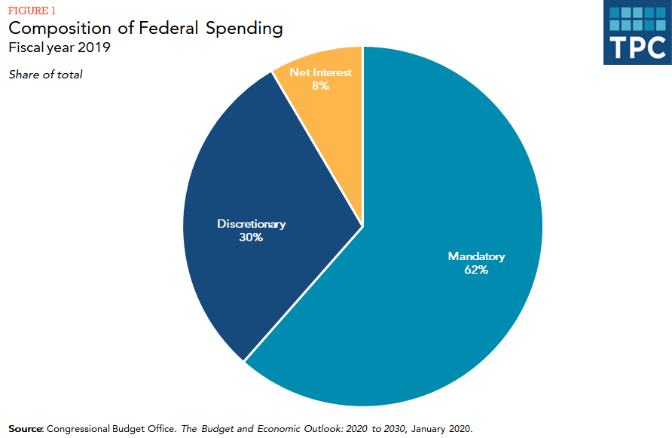

### The Federal Budget Process

The **Federal Budget** is like a home budget, with income and expenses. The U.S. Government’s fiscal year goes from October 1st of one year to September 30th of the next year. Work on the budget begins about a year and a half before the budget is finalized.

First, departments and agencies submit their proposals to the White House. Then the President submits their budget plan to Congress. Each chamber of Congress analyzes the proposal and makes their own budget resolution. Then a conference committee of House and Senate members resolves the differences between the two plans and makes a final version that each chamber votes on.

After the budget is passed, the Senate and House Appropriations committees distribute the discretionary part of the funding among 12 subcommittees that oversee different groups of agencies. As before, conference committees meet to merge the two versions of the appropriations bills. All 12 bills must be passed by both the Senate and the House and then signed by the President to enact the new budget.

If any appropriations bill is not signed by September 30th, there is no budget for the new fiscal year. In this case, Congress must pass a **continuing resolution** to temporarily fund the government. If they do not, or if the president does not sign it, the governement will shut down. The last **government shutdown** went from December 22, 2018 to January 25, 2019. This was the longest shudown in U.S. history and left over 800,000 federal workers either working without pay or being furloughed at home[11].

### The Federal Surplus or Deficit

If the government spends less than it collects in income, there will be a budget **surplus** for that year. If it spends more than it collects, there will be a **deficit** for that year. It is also possilbe to have a **balanced budget** where the spending equals the income. The federal deficit refers to the budget shortfall in a single time period, like a quarter or a year. For example, in the Fiscal Year 2018, the U.S. deficit was $779 billion. The graph below shows the federal defecit or surplus each year since 1974[12].

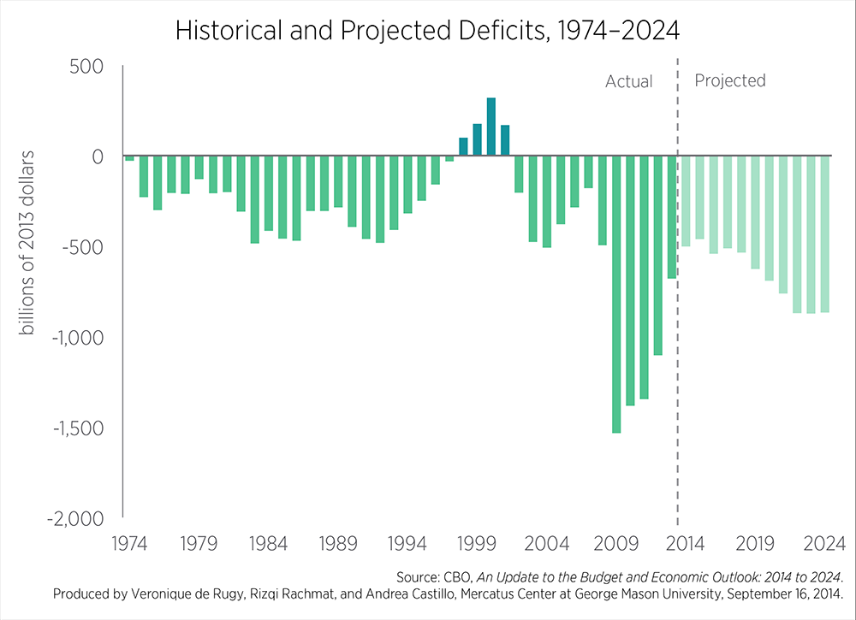

It is hard to find graphs with a vertical axis in dollars becase the value of the dollar changes over time. One dollar in 1974 could buy a lot more than it can today. In the graph above they converted each year to the equivalent of 2013 dollars to account for that. The vertical scale is in billions of 2013 dollars. The largest deficits in 2009 to 2012 were from spending and corporate bailouts to recover from the Great Recession of 2008.

On the graph above, a 1 on the vertical scale is one billion dollars or $1,000,000,000. The highest deficits go down to about -$1,500 billion, which we would write as -$1,500,000,000,000. Here is a chart that shows large numbers and how many zeros they have.

|  |  |
| --- | --- |
| Number | Name |
| $1,000 | One thousand |
| $1,000,000 | One million |
| $1,000,000,000 | One billion |
| $1,000,000,000,000 | One trillion |
| $1,000,000,000,000,000 | One quadrillion |
| $1,000,000,000,000,000,000 | One quintillion |

Instead of writing all the zeros, we can abreviate large numbers using decimals. For example, 1,200,000 can be written as 1.2 million. We can write 900,000 as 0.9 million. We can also translate the other way and write 4.567 trillion as 4,567,000,000,000. Note there can be more than one way to write a number. We could write 400,000,000 as either 400 million or 0.4 billion. It is convenient that we put the decimal where the comma goes and vice versa.

Example 1:

Write each number using a decimal abreviation.

1. 4,873,000
2. 1,500,000,000
3. 500,000,000,000
4. 8,300,000

Solution in a drop down box

Our method is to find the millions place which is the 7th digit from the right. If the number starts there, use millions. If the number is larger, count 3 more places for billions and 3 more places for trillions.

1. 4,873,000 = 4.873 million
2. 1,500,000,000 = 1.5 billion
3. 500,000,000,000 = 500 billion or 0.5 trillion
4. 8,300,000 = 8.3 million

Example 2:

Write each number in expanded form.

1. 5.7 million
2. 9.22 trillion
3. 100.2 billion
4. 0.25 trillion

Solution in a drop down box

Our method is to put a comma where the decimal is and then add zeros to get to the right place value. If the decimal is less than one, we move down to the next lower grouping as shown in part d.

1. 5.7 million = 5,700,000
2. 9.22 trillion = 9,220,000,000,000
3. 100.2 billion = 100,200,000,000
4. 0.25 trillion = 250 billion = 250,000,000,000

### Debt to GDP Ratio

A more common way to measure the defecit is as a percentage of the Gross Domestic Product. The **Gross Domestic Product**,or **GDP**, is the total value of all the finished goods and services produced within a county’s borders in a specific period of time. The GDP is a measure of the size of an economy. The growth rate of the GDP is one measure of a nation’s economic health[13]. The GDP of the United States in 2019 was $21.43 trillion[14].

Now we can look at more graphs that are written in terms of the percent of GDP. Here is a graph of federal spending and revenues as a percentage of the GDP.



For each year, if we take the revenue and subtract the spending, we get the budget surplus or deficit. If the result is negative it is a deficit. And here is a graph of the deficits in terms of percentage of GDP[15].

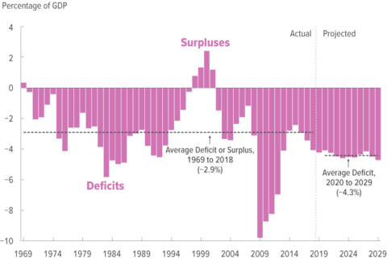

### National Debt

The words deficit and debt are easily confused because they have similar meanings. The **deficit** is the yearly shortfall, and the national **debt** is the total cumulative amount of debt held by the government.

As you can see from the previous graphs, most years had a budget deficit. If we add all of those up over time, this is what the national debt looks like[16].



Just like we pay interest on our personal debt, the U.S. pays interest on the national debt. The interest on the debt is expected to keep increasing as shown in this graph[17].



### U.S. Debt Clock

The numbers are always changing, so to see the current amount of national debt, go to the [US Debt Clock](https://www.usdebtclock.org) website. The screenshot below was taken from the site on July 22, 2020:

This is just one part of the debt clock. It shows us the total of the national debt, the debt per citizen and debt per taxpayer. It also shows us the spending and deficit with counters that are constantly moving. At the bottom you can also see the debt to GDP ratio compared with previous ratios. The rest of the website shows statistics like the U.S. population, GDP, income tax revenue, median income, unemployment and much more. You can also see statistics for other states and countries.

Now let’s do some calculations with these large numbers in the next example.

**Example 3**

Here are some approximate values for the U.S. from the fiscal year 2018: October 1, 2018 to September 30, 2019.

Federal Budget (Spending): $4.407 trillion

Federal Revenue Estimate: $3.422 trillion

National Debt: $21.803 trillion

Interest on the National Debt for 2018: $332.637 billion

Gross Domestic Product: $20.656 trillion

Population: 329 million people

a. Calculate the budget surplus or deficit for this fiscal year.

b. Calculate the debt to GDP ratio as a percentage.

c. How much debt does the U.S. have per person (per capita)?

d. How much interest is due on the national debt per person?

Solution

a. To calculate the budget surplus or deficit, we subtract the spending from the revenue, and we get



The result is negative, so there is a deficit of $985 billion. The word deficit indicates that the number is negative. If we wrote a deficit of -$985 billion that would be a double negative.

b. To calculate the debt to GDP ratio, we divide using the order of the wording. For example, the ratio of a to b would be a:b or a÷b. So, we will take the total amount of national debt and divide it by the GDP:



The debt to GDP ratio is 106%.

c. “Per” is another key word for division, so to calculate the debt per capita or per person, we divide the national debt by the population.



Notice that the debt is written in trillions and the population is in millions, so we can’t divide these numbers yet. We need to put them into the same units. We can either write both of them in expanded form like this:



Or instead of writing out all the zeros, we can convert one of the numbers to match the other. In this situation it seems easier to convert $21.803 trillion to 21,803,000 million and then divide.



d. To find out how much interest is due on the national debt per person, we will divide the interest by the population.



Again, the units do not match. This time we will convert the other way and change 329 million people into 0.329 billion people, and we have:



Or you can always write out all the zeros like this and get the same answer.



**Example 4**

One advantage of the Debt to GDP ratio is you can compare different countries with economies of different sizes. Let’s look at South Korea for comparison. Here are some approximate values, from 2020[18]. The unit of money in South Korea is the South Korean won, ₩.

Population: 50.617 million people

National Debt: ₩754.835 trillion

Gross Domestic Product: ₩1.731 quadrillion

Interest Payments per year: ₩30.055 trillion

1. Calculate the debt to GDP ratio as a percentage.
2. Calculate the amount of debt per person.
3. Calculate the amount of interest paid per year per person.

Solution in a drop-down box

1. First, we divide the amount of debt by the GDP.



Since one of the numbers is in trillions and the other in quadrillions, we have to make them match before we can divide. We will change the GDP into Trillions:

 or 44%.

1. To find the amount of debt per person, we divde the debt by the number of people.



Again the units don’t match so we must either write all the zeros or make sure they are in the same units. In this case we will change the debt into millions but there are many ways you could do it.

per person

1. To find the amount of interest paid per year per person, we divde the amount of interest by the number of people.



We will change the interest to millions and divide.

per person.

For more comparisons, here is a graph showing the debt to GDP ratios around the world in 2020[19].

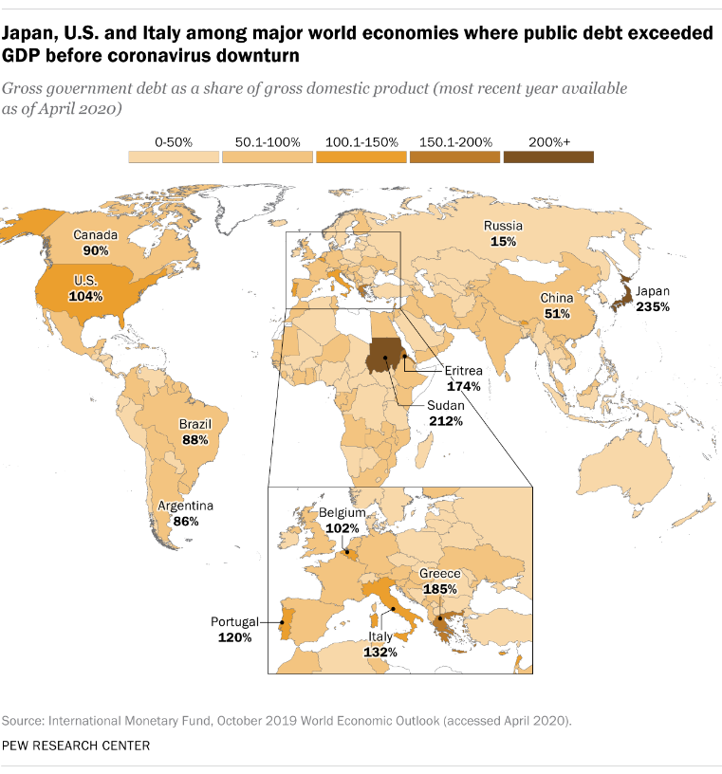

### Pie Charts and Percentages

We can also do calculations with large numbers that involve percentages. We will look at some pie charts related to government income and spending.

**Example 5**

In Example 3, we saw that the federal revenue estimate for 2019 was $3.422 trillion. Use the pie chart[20] to calculate the dollar value of each revenue source shown in the graph.

Solution

There are 4 segments in the pie chart, showing 4 different types of revenue. For each type, we will multiply the decimal form of the percentage by the total revenue:

Individual Income Taxes: (0.56)($3.422 trillion) = $1.916 trillion

Social Security Taxes (Payroll Taxes): (0.36)($3.422 trillion) = $1.232 trillion

Corporate Taxes and Other: (.02)($3.422 trillion) = $0.0684 trillion or $68.4 billion

Ad Valorum (Excise Taxes and other): (.06)($3.422 trillion) = $205.3 billion

**Example 6**

In Example 3 we saw that the total amount of the federal budget in 2019 was $4.407 trillion. Use the pie chart of federal spending[21] below to calculate the dollar amounts of each of the following types of spending.

a. Defense

b. Social Security Payments

c. Healthcare

d. Education

Solution in drop down box

We will take the decimal form of the percentage of each type of spending and multiply it by the total budget amount of $4.407 trillion.

a. Defense: (0.22)($4.407 trillion) = $0.9695 trillion or $969.5 billion

b. Social Security: (0.25)($4.407 trillion) = $1.102 trillion

c. Healthcare: (0.28)($4.407 trillion) = $1.233 trillion

d. Education: (0.03)($4.407 trillion) = $0.1322 trillion or $132.2 billion

In this chapter, we have looked at many important quantitative aspects of government: apportionment, voting methods, how the president is chosen, gerrymandering and the federal budget. Filling out the census, being informed and voting are extremely important for the U.S. democracy. Please make up your own mind and vote if you are eligible.

## Exercises 5.5

1. Write each number using a decimal abreviation.

1. 4,873,000
2. 1,500,000,000
3. 500,000,000,000
4. 8,300,000

2. Write each number using a decimal abreviation.

1. 63,651,000,000,000
2. 93,600,000
3. 119,930,000,000
4. 6,001,000,000

3. Write each number in expanded form.

1. 5.7 million
2. 9.22 trillion
3. 100.2 billion
4. 0.25 trillion

4. Write each number in expanded form.

1. 0.57 quadrillion
2. 1.57 billion
3. 9.07 trillion
4. 800 million

For each country[22], find

1. The debt to GDP ratio as a percentage.
2. The amount of debt per person.
3. The amount of interest paid per year per person.
4. In Columbia, the unit of currency is the Columbian peso, abbreviated as COP$ or C$.

Population: 48.9 million people

National Debt: C$ 270.978 trillion

Gross Domestic Product: C$ 491.504 trillion

Interest Payments per year: C$ 16.628 trillion

1. In Pakistan, the unit of currency is the Pakistani rupee or Rs.

Population: 209.7 million people

National Debt: Rs 24.255 trillion

Gross Domestic Product: Rs 27.354 trillion

Interest Payments per year: Rs 2.033 trillion

1. In Poland, the unit of currency is the złoty, or  zł.

Population: 38,492,299 people

National Debt: 1.223 trillion zł

Gross Domestic Product: 1.981 trillion zł

Interest Payments per year: 52.500 million zł

1. In Australia, the unit of currency is the Australian dollar, AUD or A$.

Population: 24.711 million people

National Debt: A$ 645.316 billion

Gross Domestic Product: A$ 1.927 trillion

Interest Payments per year: A$ 19.73 billion

1. In South Africa, the unit of currency is the South African rand or R.

Population: 54.5 million people

National Debt: R. 3.736 trillion

Gross Domestic Product: R. 6.186 trillion

Interest Payments per year: R. 196.843 billion

1. In Malaysia, the unit of currency is the Malaysian ringgit or RM.

Population: 54.5 million people

National Debt: RM. 792.474 billion

Gross Domestic Product: RM. 1.444 trillion

Interest Payments per year: RM. 27.682 billion

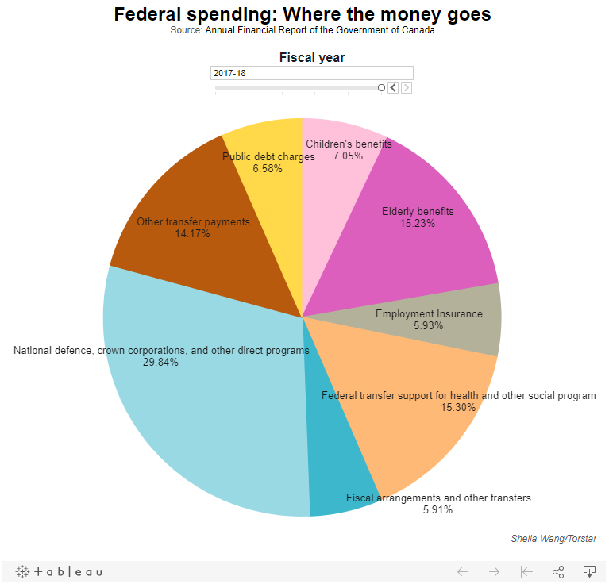11. If Canada collected $311.2 Billion of tax revenue in 2017-18, and their population was 37.06 Million people, use the pie chart[23] to calculate how much was spent on

a. Children’s benefits in total

b. Health and other social programs per person

c. Elderly benefits in total

12.

1. <https://www.history.com/topics/native-american-history/native-american-timeline>
2. <https://www.juneteenth.com/history.htm>
3. <https://www.history.com/topics/abolitionist-movement/compromise-of-1850>
4. <https://www.fairvote.org/rcv#where_is_ranked_choice_voting_used>
5. [Math in Society](http://www.opentextbookstore.com/mathinsociety/index.html): Voting Theory, by David Lippman
6. <https://ballotpedia.org/Presidential_election,_2016>
7. <http://www.electproject.org/2016g>
8. <https://mailtribune.com/news/top-stories/oregon-could-add-a-congressional-district-but-not-without-disruptive-fight>
9. <https://www.usa.gov/budget>
10. <https://www.taxpolicycenter.org/briefing-book/how-does-federal-government-spend-its-money>
11. <https://www.thoughtco.com/history-and-effects-of-government-shutdowns-3321444>
12. <https://www.mercatus.org/publications/government-spending/debt-and-deficits-cbo%E2%80%99s-updated-budget-outlook-2014-2024>
13. <https://www.bea.gov/data/gdp/gross-domestic-product>
14. <https://www.bea.gov/news/2020/gross-domestic-product-fourth-quarter-and-year-2019-advance-estimate#:~:text=Current%2Ddollar%20GDP%20increased%204.1,table%201%20and%20table%203).>
15. <https://www.cbo.gov/publication/55151>
16. <https://www.pgpf.org/chart-archive/0025_federal-debt-hist>
17. <https://www.pgpf.org/analysis/2018/12/higher-interest-rates-will-raise-interest-costs-on-the-national-debt>
18. <https://commodity.com/debt-clock/southkorea/>
19. <https://www.pewresearch.org/fact-tank/2020/04/29/coronavirus-downturn-likely-to-add-to-high-government-debt-in-some-countries/>
20. <https://www.usgovernmentrevenue.com/year_revenue_2019USbf_20bs1n>
21. <https://www.usgovernmentspending.com/piechart_2019_US_fed>
22. Source: <https://commodity.com/debt-clock/>, accessed on July 22, 2020.
23. <https://medium.com/@je_12591/how-is-tax-revenue-spent-in-canada-7bd50afb140a>